Non PO Voucher eForm
This topic shows how Medical School users will complete and submit an ImageNow eForm to request a Non PO Voucher.

A link to access this eForm can be found on the web site for the Medical School Office of Finance.
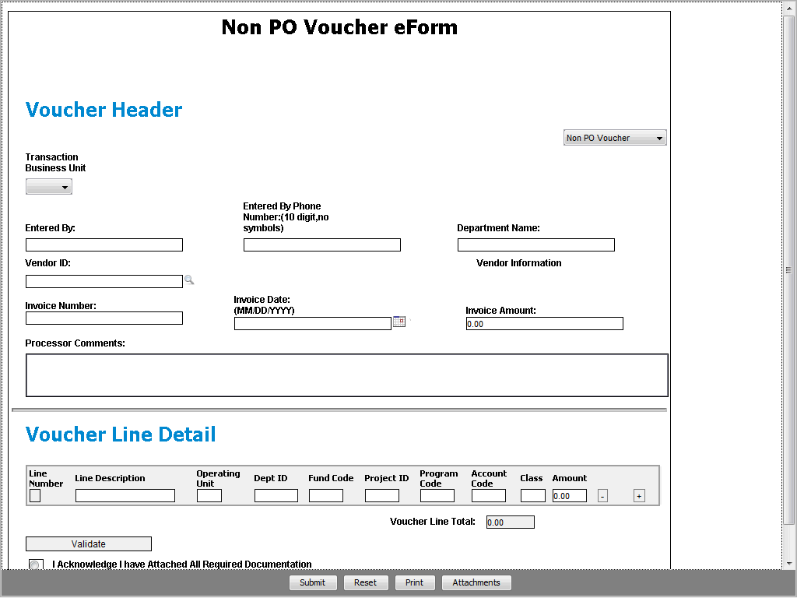

Step | Action
When you click the link for eForms, the Non PO Voucher eForm appears in the Voucher Header by default.

If needed, use the right side of the Voucher Header to select the Non PO Voucher eForm.

Click the Voucher Type dropdown button to activate the menu.

Step | Action
 | Click the Non PO Voucher list item.
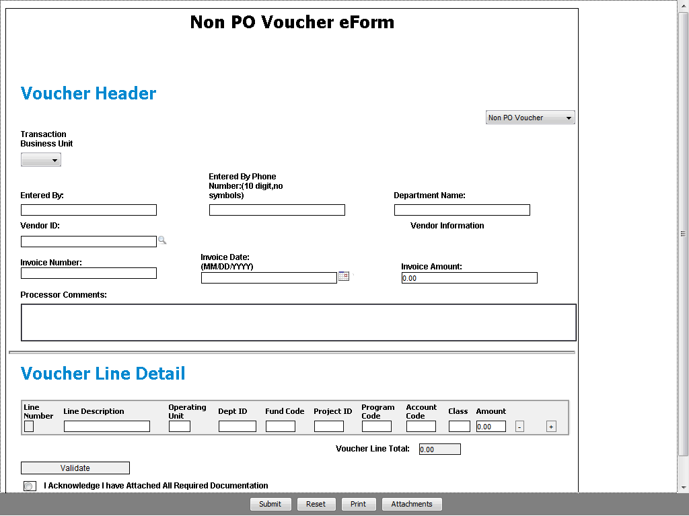

Step | Action
 | Click the Transaction Business Unit dropdown button to activate the menu.

Step | Action
Select the UTHSC or the UTP business unit as needed.

Click the UTHSC list item.
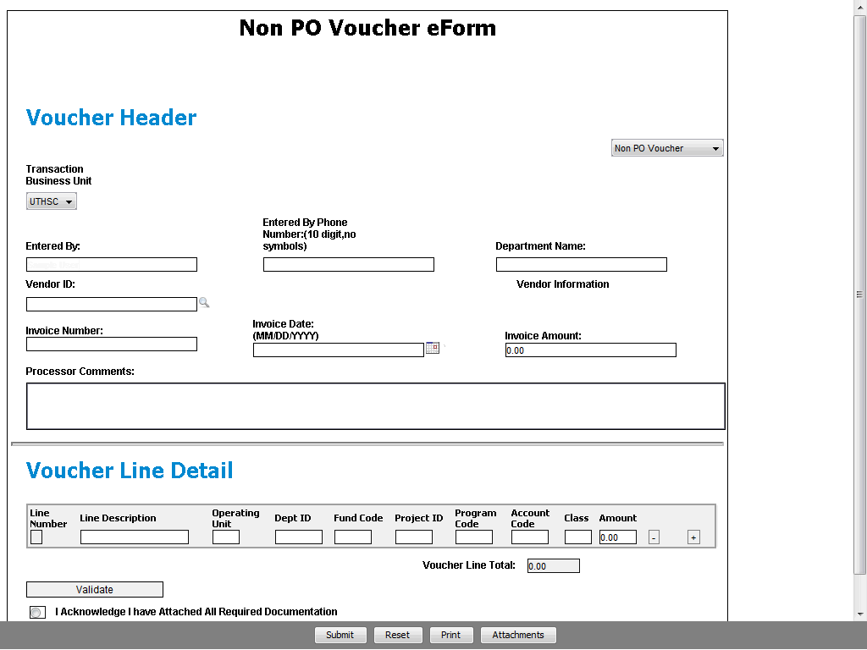

Step | Action
Enter your full name in the Entered By: field.

Enter the desired information into the Entered By: field. Enter "Sample User".

Step | Action
Enter your area code and work telephone number. No special characters are needed here.

Enter the desired information into the Entered By Phone Number: field. Enter "7135001234".

Step | Action
Your phone number is formatted when you move to the next field on the eForm.

Enter the name of the department where you work. This may not necessarily be the same as the department used in the ChartField String.

Enter the desired information into the Department Name field. Enter "Psychiatry".
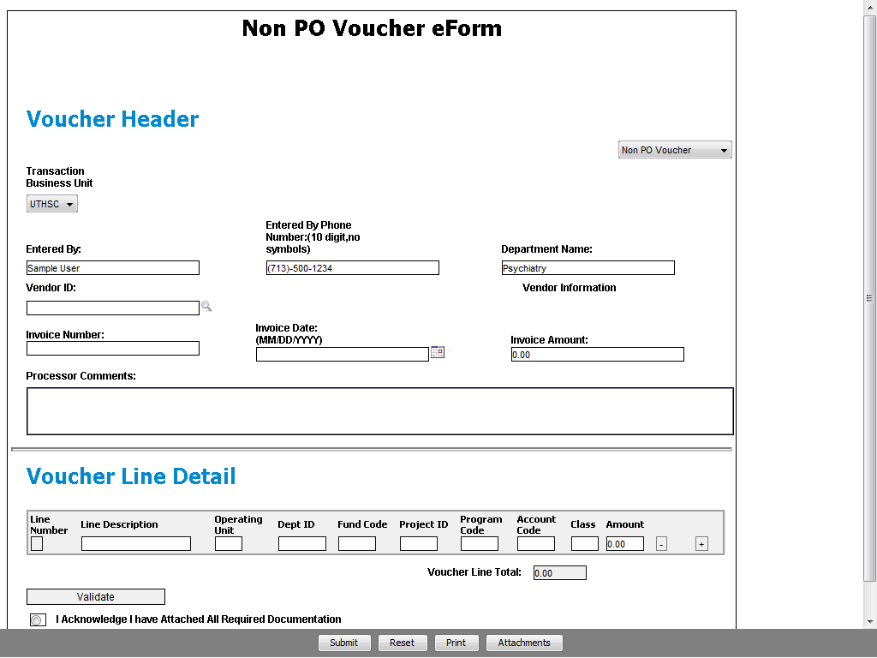

Step | Action
Enter the 10-digit Vendor ID or use the Look up Vendor ID button to search for a vendor/supplier.

This example will demonstrate both search methods.

Enter the desired information into the Vendor ID field. Enter "0000014481".
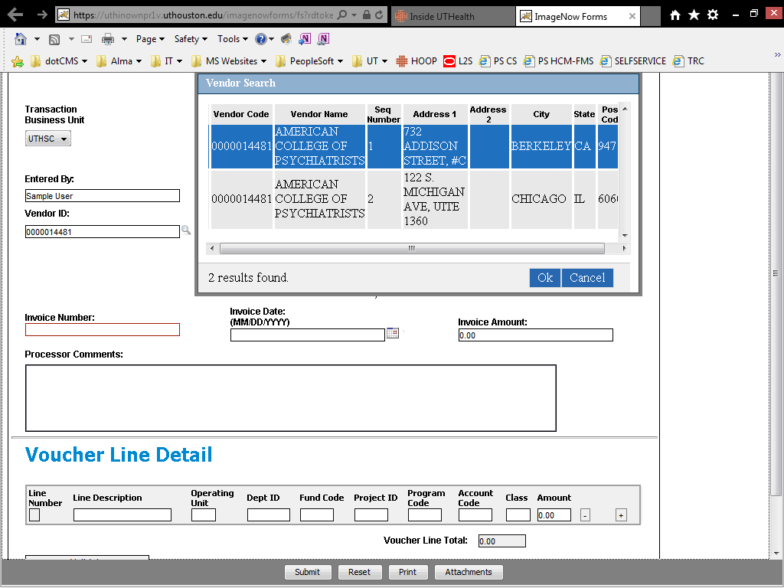

Step | Action
When you enter the Vendor ID and move to the next field, or click the Look up Vendor ID button, the Vendor Search pop-up window appears with address options for the vendor.

Double-click the vendor address to which payment should be sent (or click the address and click Ok).

Double-click an entry in the Vendor Search rows.
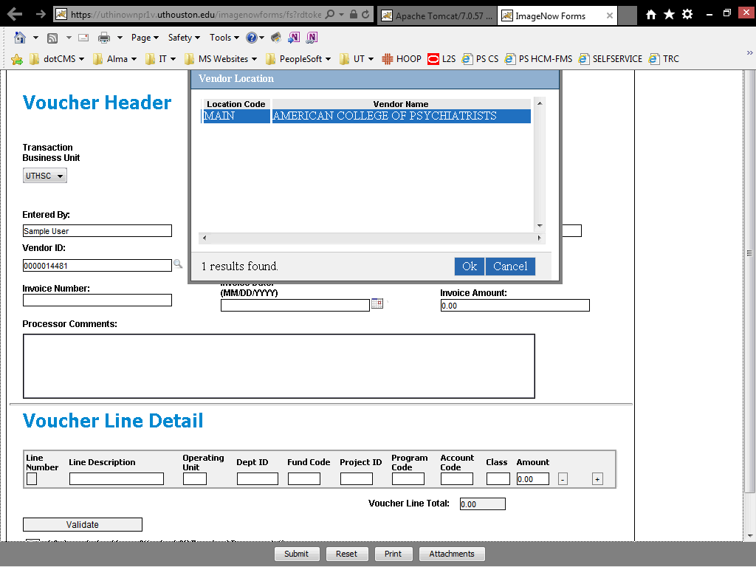

Step | Action
Next the Vendor Location pop-up window appears with one or more location options.

Because Vendor and Address Sequence Number (selected on the previous search screen) will be used to build the voucher and to populate Payment Address and Payment Method, you can usually choose "MAIN" as the Location on the Location selection screen.

The exception to selecting "MAIN" is when a different payment method is required (i.e., CHECK, EFT, WIRE) for your transaction. For instance, when sending research-related payments from UTH to UTP, the location is not the "MAIN" location, but is one that lists "CHECK" as the Payment Method.

Double-click an entry in the Vendor Search rows.
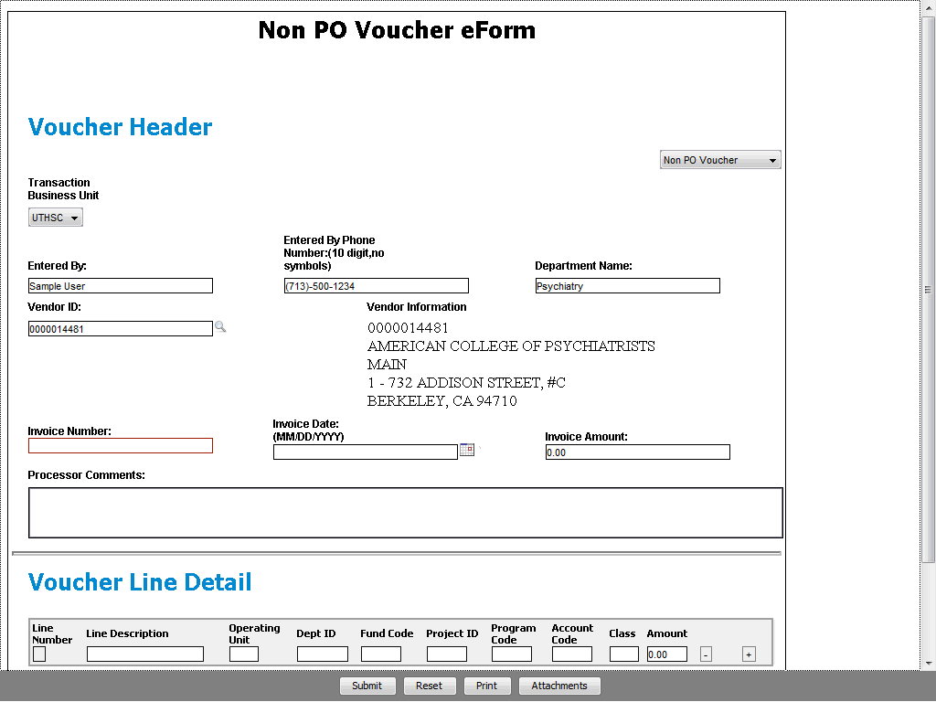

Step | Action
 | The selected vendor ID, name, and address display under Vendor Information.

Step | Action
Now see another way to search for a vendor/supplier.

Click the Look up Vendor ID button.
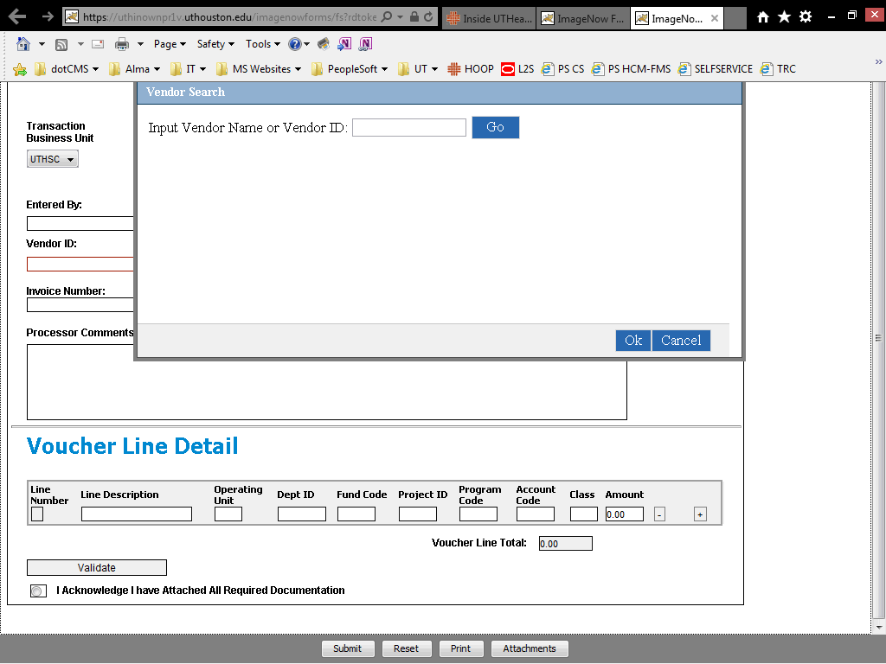

Step | Action
A blank Vendor Search pop-up window appears where you can search by vendor name or ID.

Enter the desired information into the Input Vendor field. Enter "American College of Psychiatrists".

Step | Action
 | Click the Go button.

Step | Action
The Vendor Search pop-up window appears with address options for the vendor.

Double-click the vendor address to which payment should be sent (or click the address and click Ok).

Double-click an entry in the Vendor Search rows.

Step | Action
Next the Vendor Location pop-up window appears with one or more location options.

Because Vendor and Address Sequence Number (selected on the previous search screen) will be used to build the voucher and to populate Payment Address and Payment Method, you can usually choose "MAIN" as the Location on the Location selection screen.

The exception to selecting "MAIN" is when a different payment method is required (i.e., CHECK, EFT, WIRE) for your transaction. For instance, when sending research-related payments from UTH to UTP, the location is not the "MAIN" location, but is one that lists "CHECK" as the Payment Method.

Double-click an entry in the Vendor Location rows.

Step | Action
The selected vendor ID, name, and address display under Vendor Information.

Enter the vendor's Invoice Number exactly as it appears on the bill; spaces and special characters are allowed.

Enter the desired information into the Invoice Number field. Enter "12345".
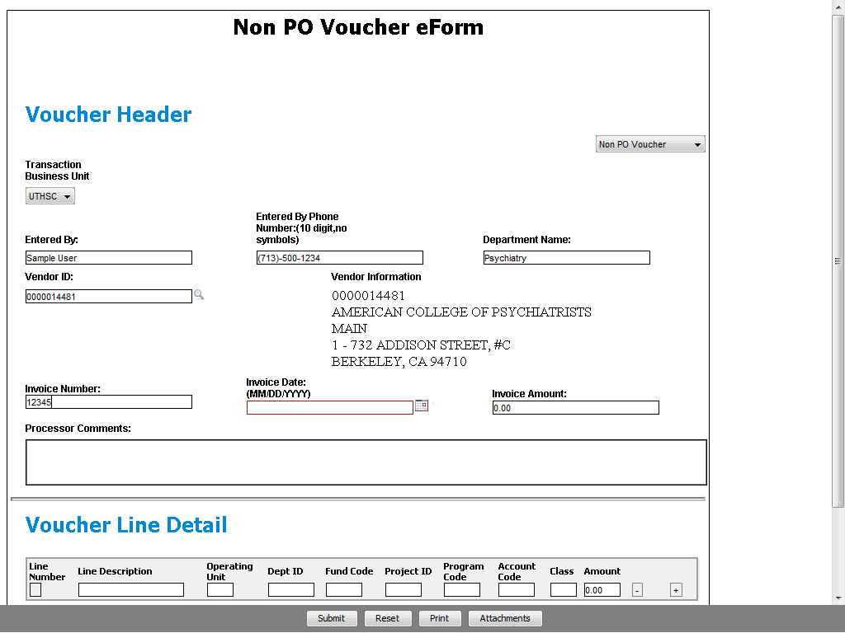

Step | Action
Invoice Date is not an input field. Click in the Invoice Date field, or click the Calendar button to select a date from the pop-up calendar.

Select the date on the vendor's invoice or use today's date if no date is provided.

Click the Calendar button.
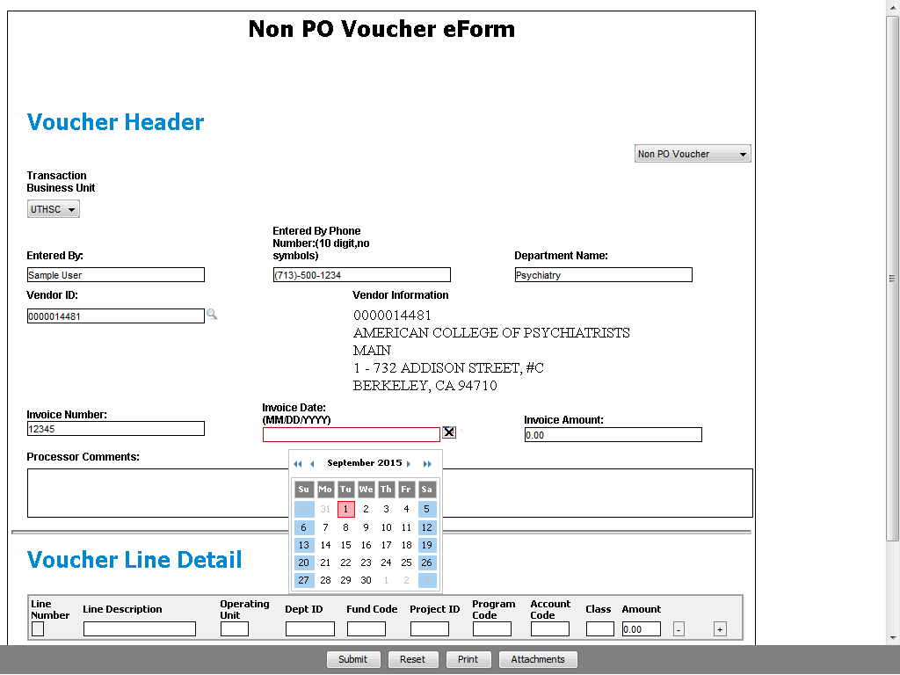

Step | Action
Scroll to the desired month/year.

Click the Previous/Back button.

Step | Action
Select the date for the selected month/year.

Click the Aug 10 object.
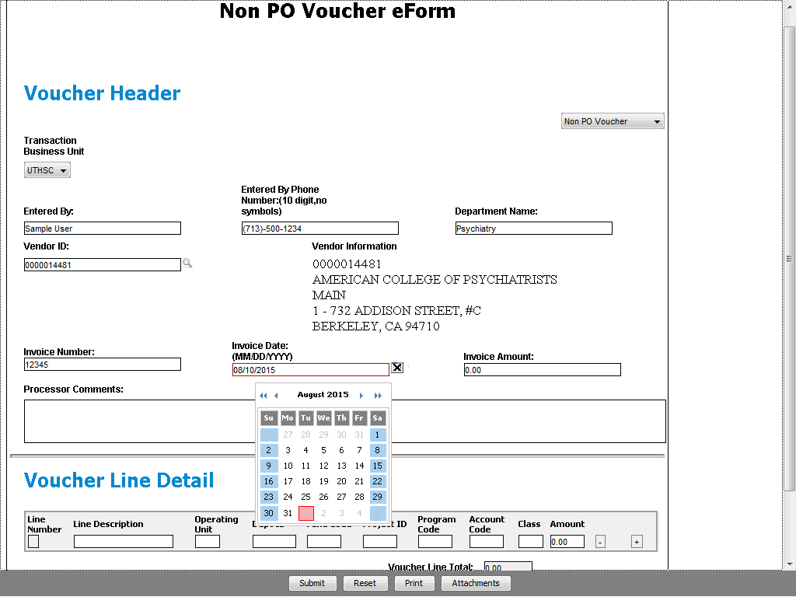

Step | Action
Close the calendar pop-up window when the correct Invoice Date displays in the field.

Click the Close Calendar button.
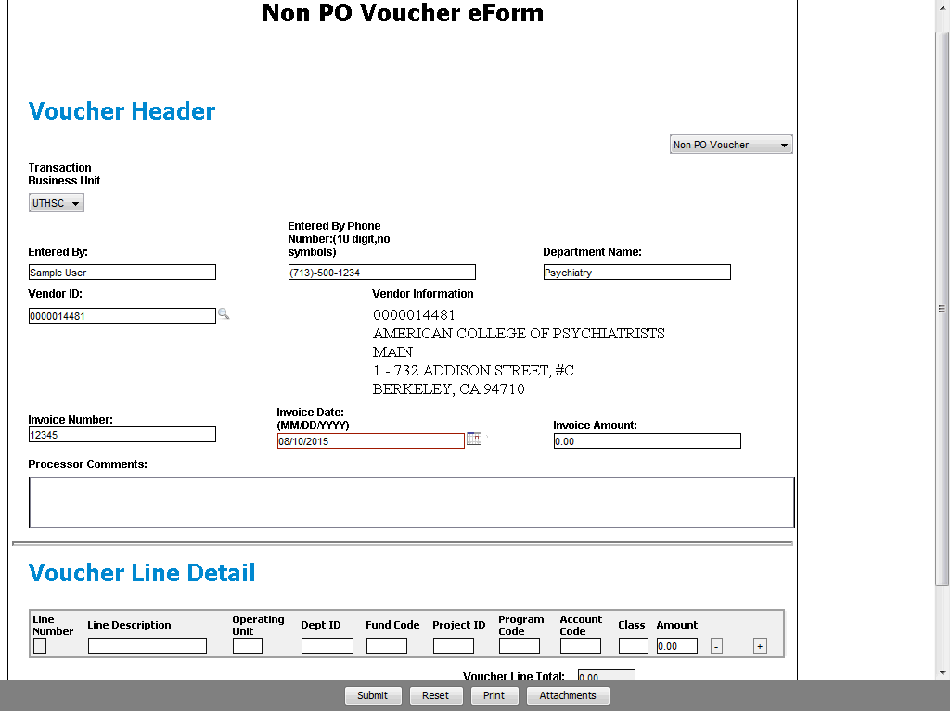

Step | Action
Enter the total amount of the invoice.

Enter the desired information into the Invoice Amount field. Enter "2000".

Step | Action
The Invoice Amount is formatted when you move to the next field.

In the Voucher Line Detail section, enter the appropriate Line Description, ChartField String, and Amount. As needed, click the (+) Add a New Row button to add additional voucher lines and enter the details.

Click the Vertical scrollbar.
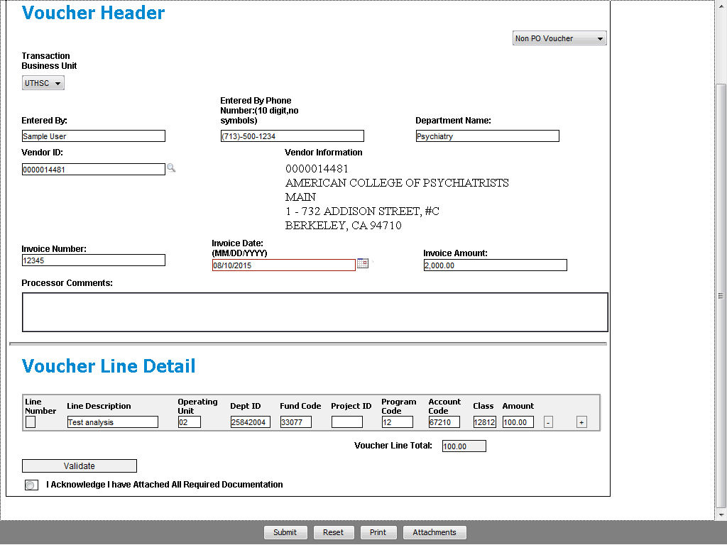

Step | Action
Once you have input all of the information on the eForm, click the Validate button to check for any errors.

(In this example, the voucher line detail has been entered with an incorrect amount.)

Click the Validate button.
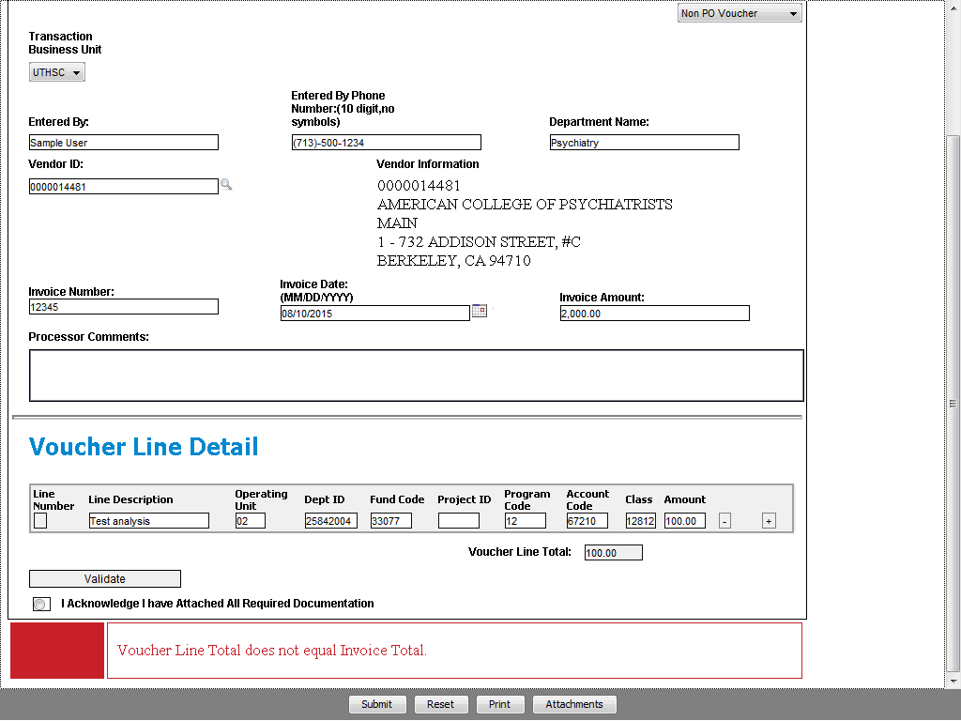

Step | Action
If needed, correct any errors or click the Reset button and re-enter the eForm data. Then validate the eForm again.

(In this example, we are correcting the voucher line detail amount.)

Enter the desired information into the Amount field. Enter "2000".

Step | Action
 | Click the Validate button.
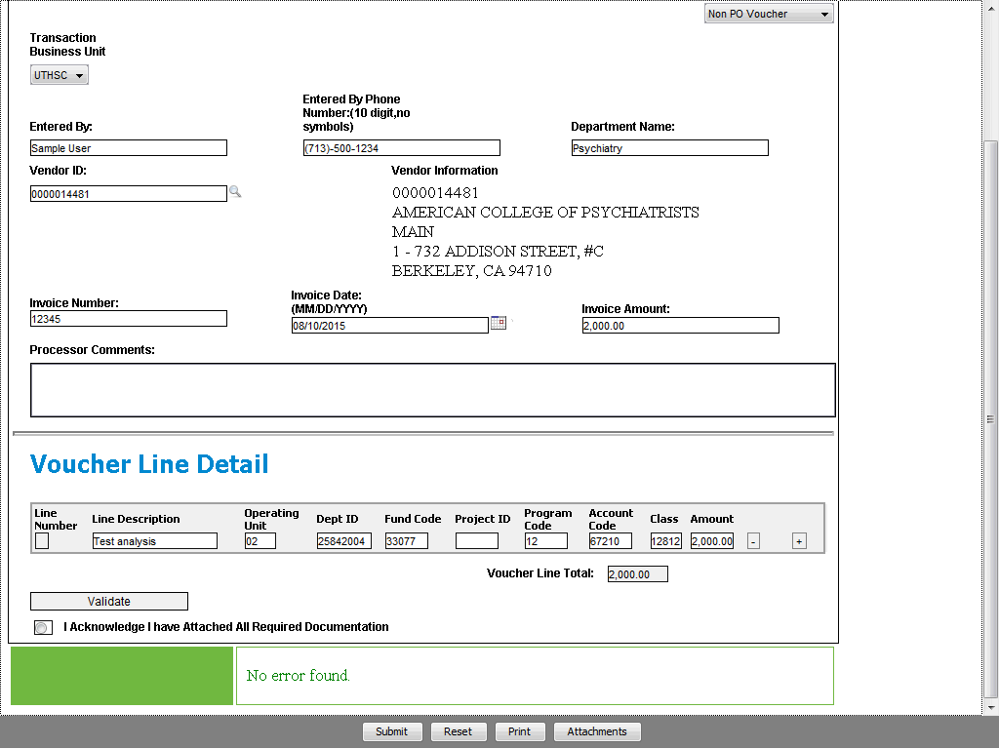

Step | Action
After you have successfully validated the eForm information, attach the supporting documentation.

Click the Attachments button.
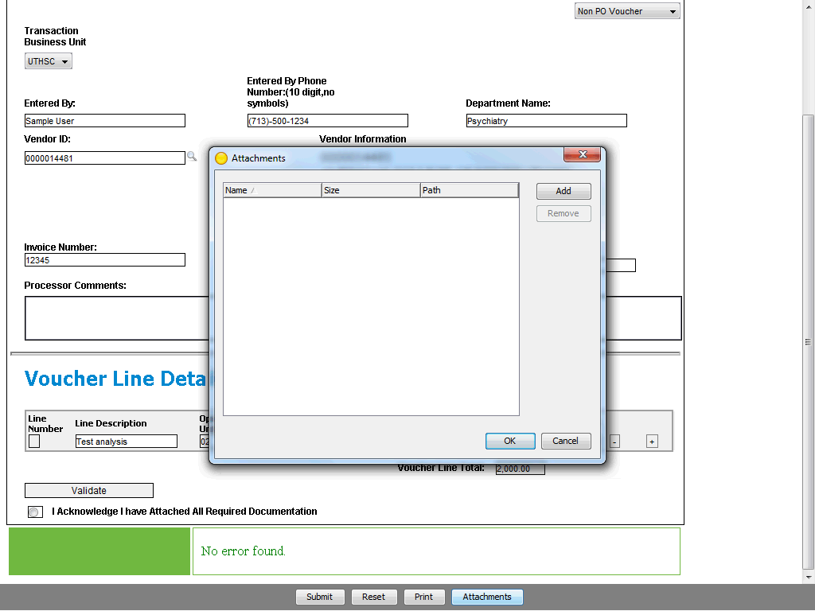

Step | Action
Click Add to search for and attach the supporting documentation for the transaction. Once all required file(s) are displayed in the Attachments pop-up window, click OK.

Click the OK button.
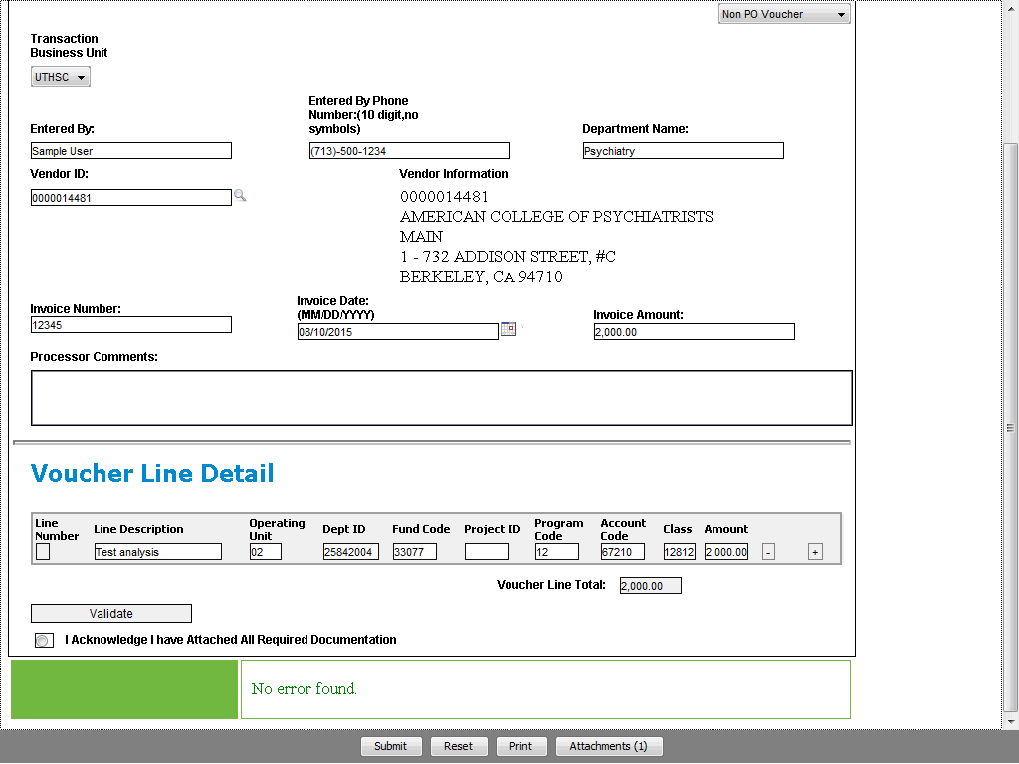

Step | Action
Notice the Attachments button indicates the number of files attached to the eForm.

Click the Acknowledge radio button option.
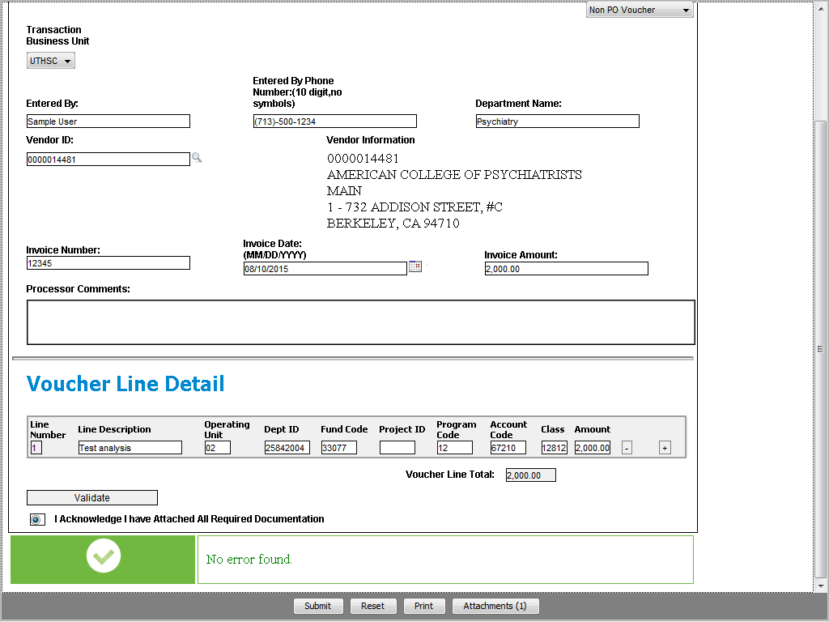

Step | Action
Optional: Use the Print button to get a copy of the completed eForm.

The last step is to submit the eForm.

Click the Submit button.

Step | Action
 | Once the eForm is submitted, a confirmation message appears.

Step | Action
You have successfully completed this topic.
End of Procedure.

