Travel Voucher eForm

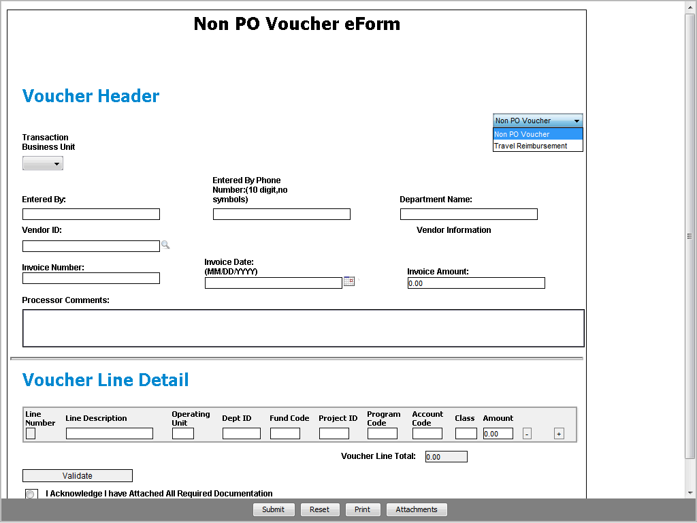

Step | Action
When you click the link for eForms, the Non PO Voucher eForm appears in the Voucher Header by default.

If needed, use the right side of the Voucher Header to select the Travel Reimbursement eForm.

Click the Voucher Type dropdown button to activate the menu.

Step | Action
 | Click the Travel Reimbursement list item.
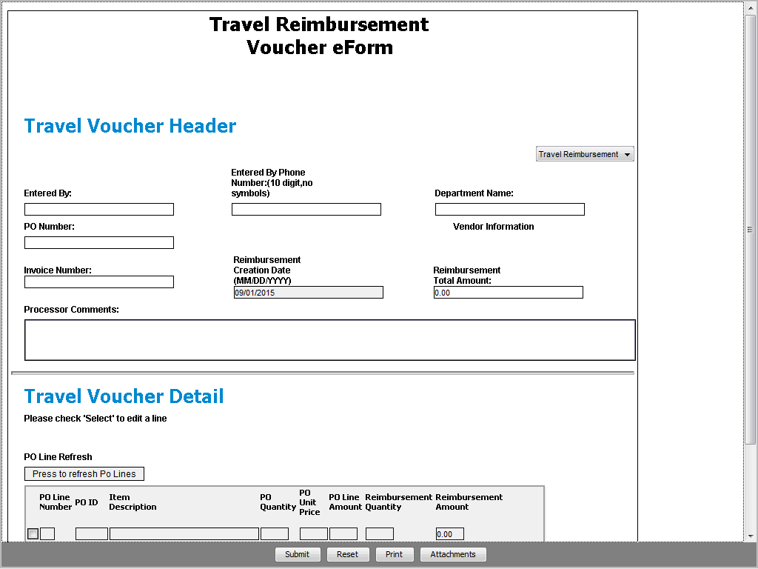

Step | Action
Enter your full name in the Entered By: field.

Enter the desired information into the Entered By: field. Enter "Sample User".

Step | Action
Enter your area code and work telephone number. No special characters are needed here.

Enter the desired information into the Entered By Phone Number: field. Enter "7135001234".

Step | Action
Your phone number is formatted when you move to the next field on the eForm.

Enter the name of the department where you work. This may not necessarily be the same as the department used in the ChartField String.

Enter the desired information into the Department Name field. Enter "Radiology".
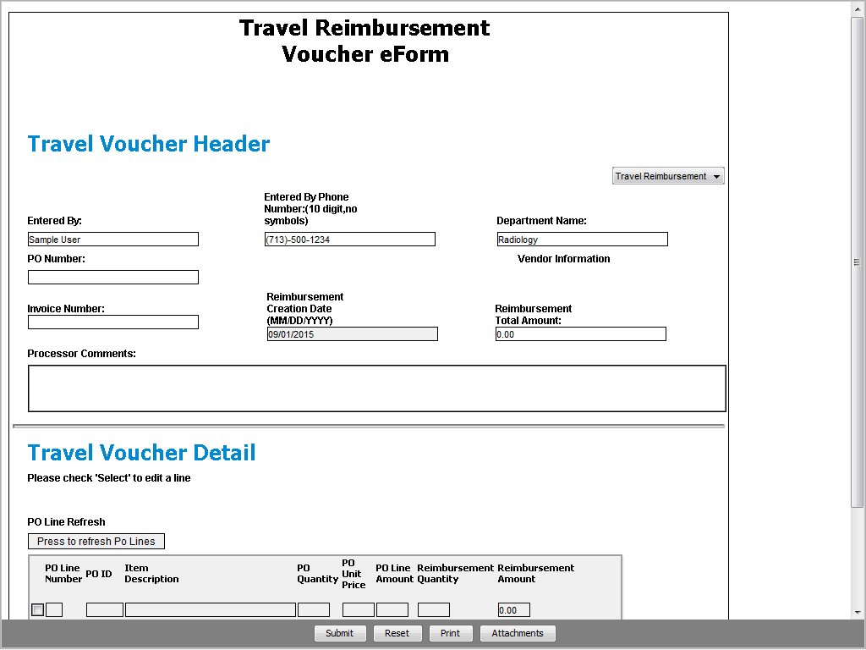

Step | Action
Enter the travel purchase order number.

Enter the desired information into the PO Number field. Enter "0000186683".

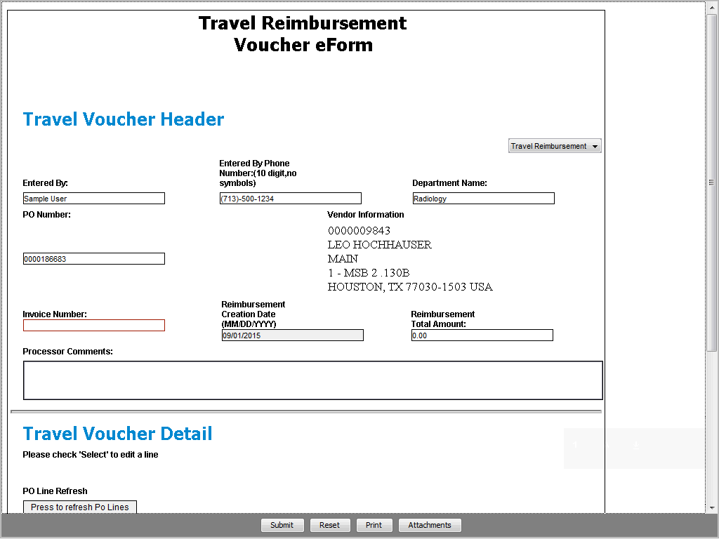

Step | Action
When you move to another field, details from the travel PO are populated on the eForm, such as the Vendor Information and PO line details.

Enter the travel Invoice Number in the recommended format:
• Registration - YYRVendorID_MMDD
• Employee expenses - YYEVendorID_MMDD
• Misc. Services/Consultant - YYCVendorID_MMDD

Enter the desired information into the Invoice Number field. Enter "15E9843_0815".

Step | Action
The Reimbursement Creation Date defaults to today's date.

Enter the total amount to be reimbursed to the vendor/supplier. This will match the amount on the Travel Expense Worksheet or Misc. Services Expense Worksheet.

Enter the desired information into the Reimbursement Total Amount field. Enter "1000".

Step | Action
 | Click the Vertical scrollbar.
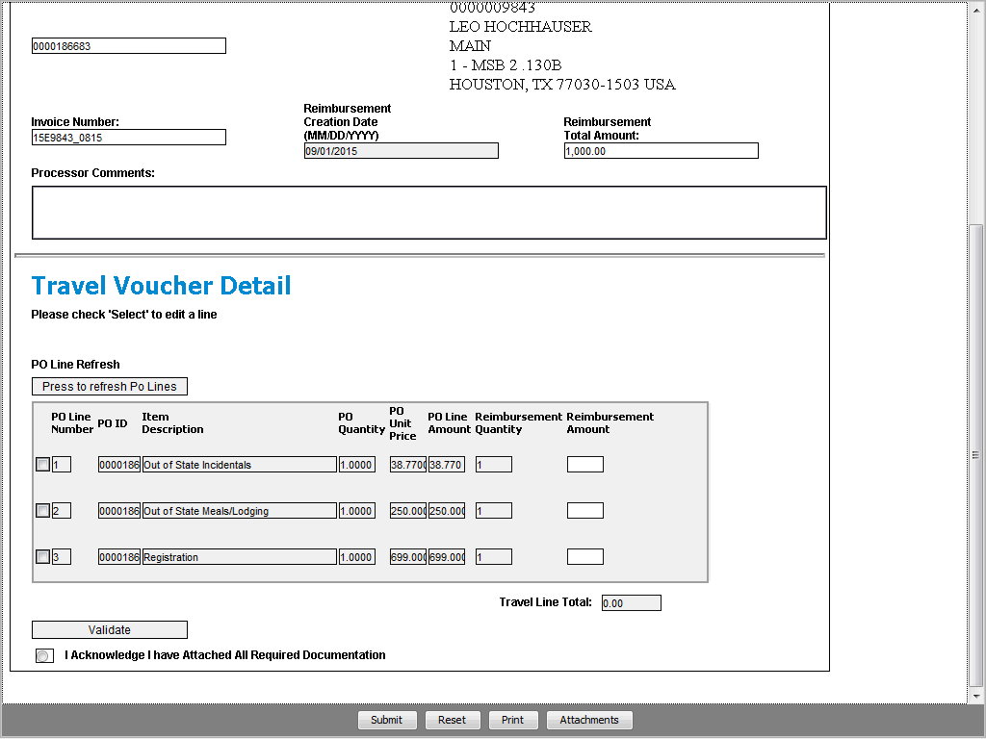

Step | Action
 | In the Travel Voucher Detail section, review the PO line information. Using the completed Expense Worksheet, select each PO Line and enter the correct Reimbursement Amount.

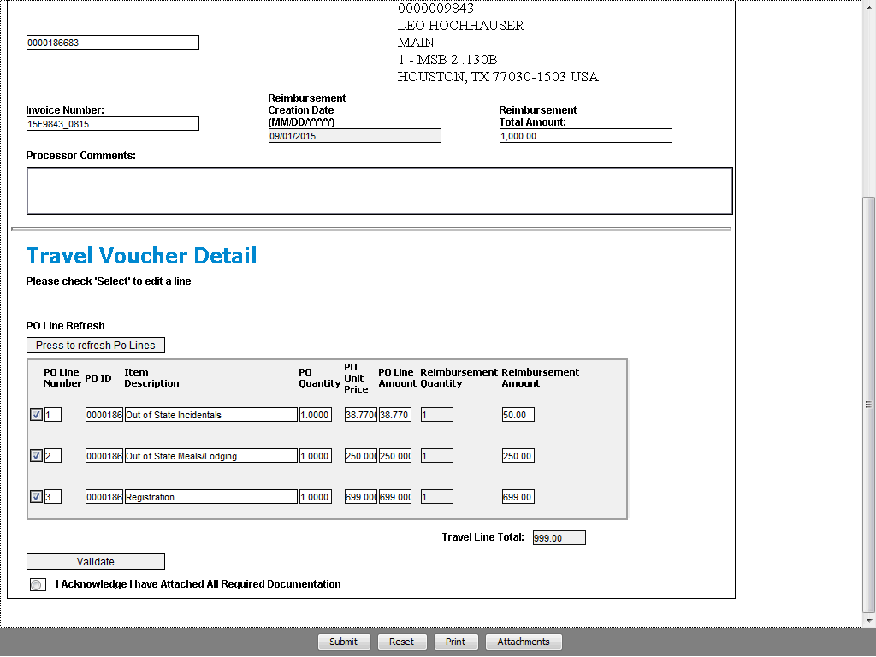

Step | Action
Once you have input all of the information on the eForm, click the Validate button to check for any errors.

(In this example, a PO line has been entered with an incorrect reimbursement amount.)

Click the Validate button.
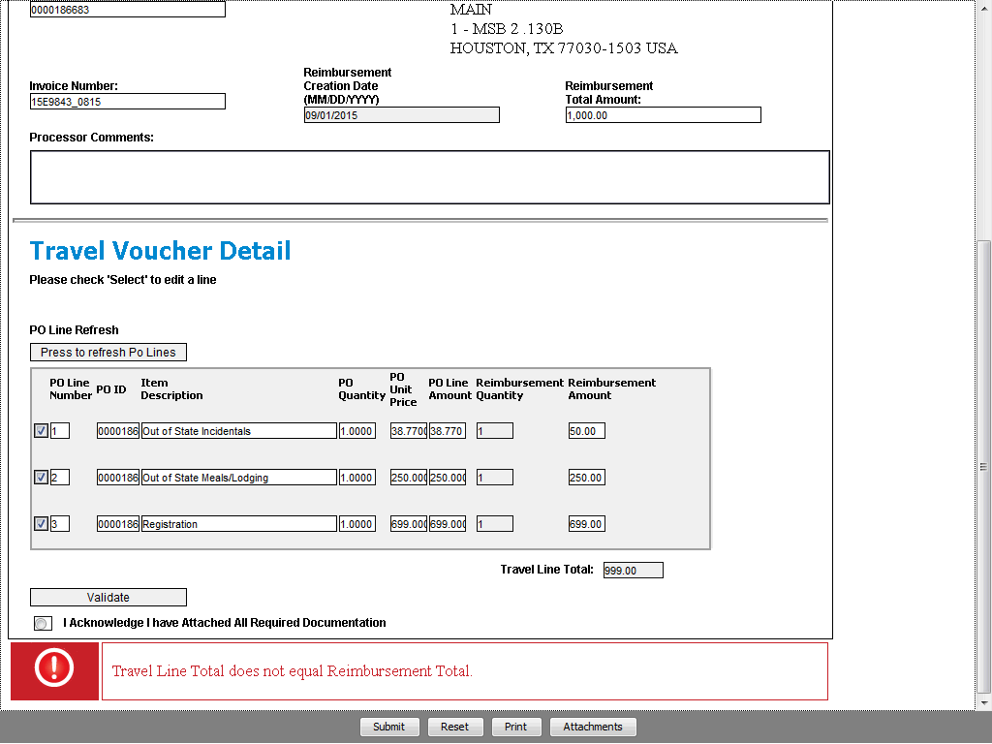

Step | Action
If needed, correct any errors or click the Reset button and re-enter the eForm data. Then validate the eForm again.

(In this example, we are correcting the reimbursement amount.)

Enter the desired information into the Reimbursement Amount field. Enter "51.00".

Step | Action
 | Click the Validate button.
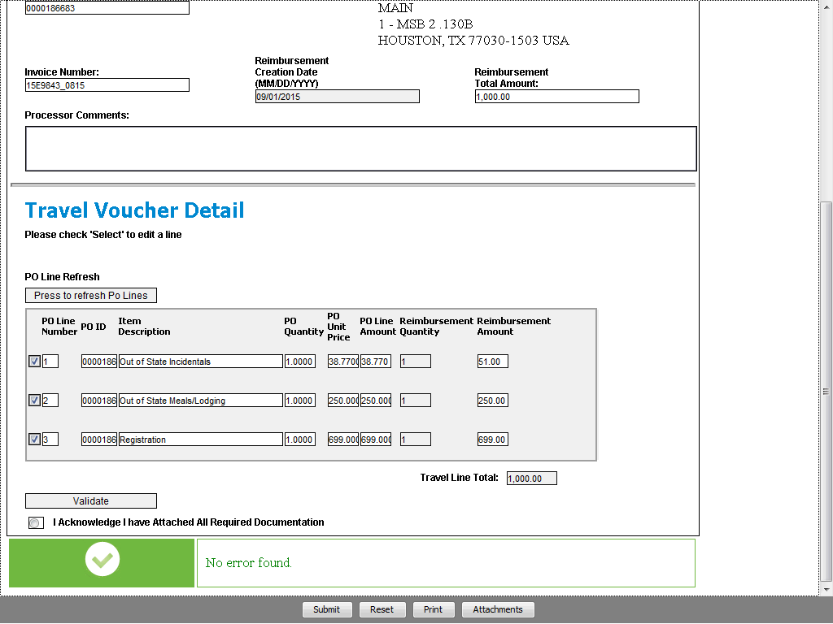

Step | Action
After you have validated the eForm information, attach the supporting documentation.

Click the Attachments button.
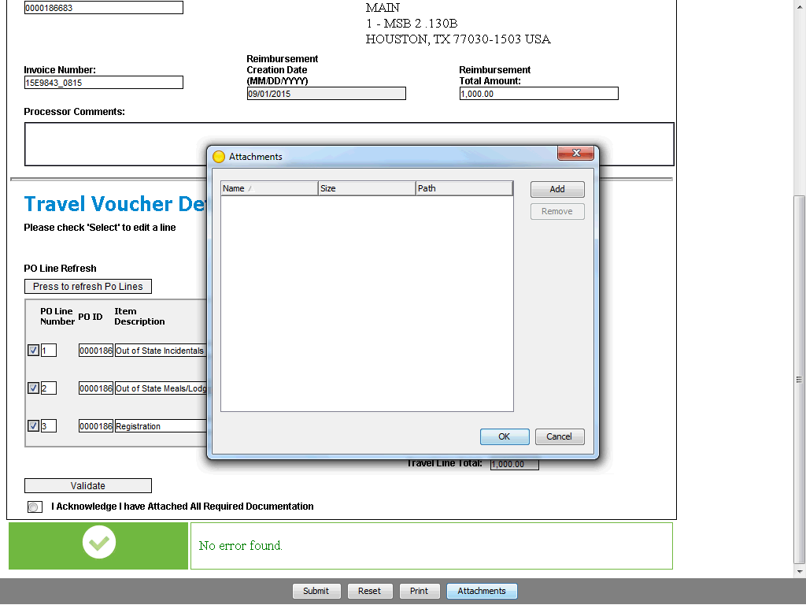

Step | Action
Click Add to search for and attach the supporting documentation for the transaction. Once all required file(s) are displayed in the Attachments pop-up window, click OK.

Click the OK button.
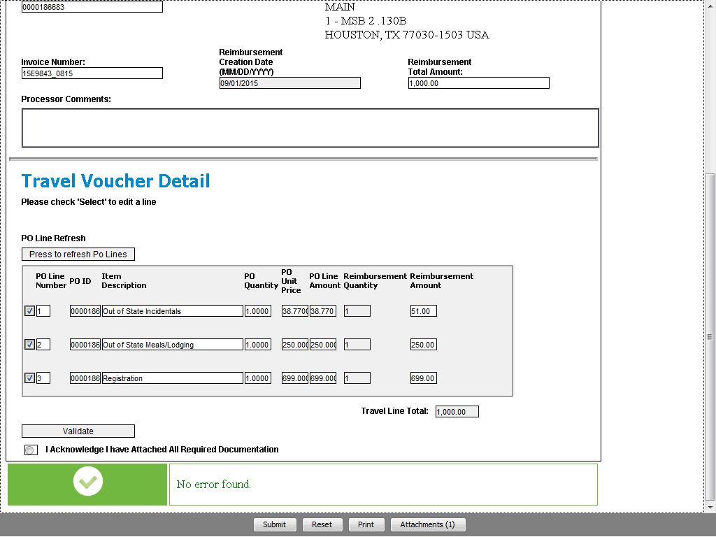

Step | Action
Notice the Attachments button indicates the number of files attached to the eForm.

Click the Acknowledge radio button option.
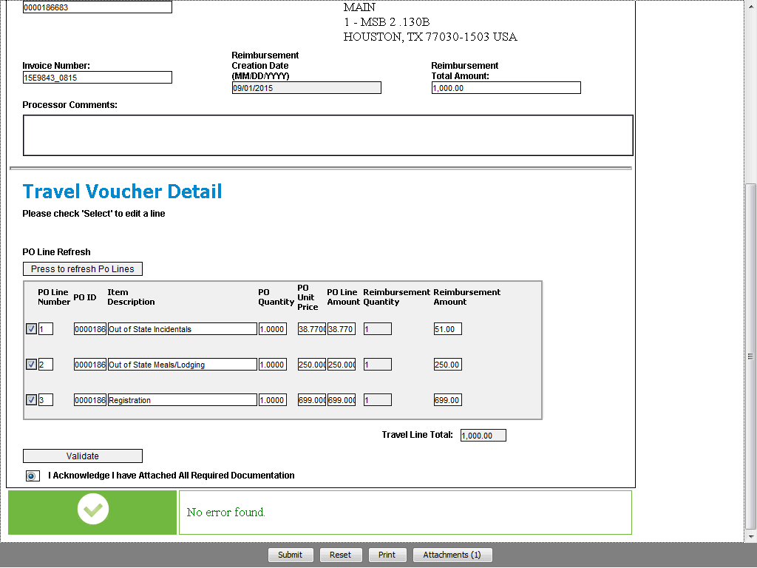

Step | Action
Optional: Use the Print button to get a copy of the completed eForm.

The last step is to submit the eForm.

Click the Submit button.

Step | Action
 | Once the eForm is submitted, a confirmation message appears.

Step | Action
You have successfully completed this topic.
End of Procedure.

