# What is a departmental account reconciliation?

A departmental account reconciliation is a comparison of a department’s monthly financial reports (e.g., FMS End Of Month (EOM) ledger sheets), which are produced by The University of Texas Health Science Center at Houston (UTHSC-H) Accounting Department, to supporting documentation which is retained in the department (e.g., file copies of approved vouchers or departmental accounting reports). This control activity helps to ensure the accuracy and completeness of transactions that have been charged to the department’s accounts.

# Why reconcile departmental accounts?

* To ensure the expenditures which have been charged to the department’s accounts were properly approved and charged to the correct account.
* To ensure that all revenues which have been earned/collected by the department have been credited and charged to the correct account.

# Who should perform departmental account reconciliations?

Each department should ensure proper separation of duties. The person who performs the departmental account reconciliations should ***not*** approve departmental expenditures or handle cash receipts. At least two sets of eyes should look at a transaction.

***What* accounts should be reconciled and *when* should reconciliations be performed?**

Ideally, ***all*** accounts assigned to the department ***should*** be reconciled ***monthly*** – General Fund accounts, State Fund accounts, Service Department accounts, Designated Fund accounts, Auxiliary Enterprises accounts, Federal Contracts/Grants accounts, State Agency Contracts/Grants accounts, Other Governmental Agencies or Local Governmental Contracts & Grants accounts, Private Gifts/Contracts & Grants accounts, etc.

# Objective

The objective of these guidelines is to instruct department personnel how to reconcile their departmental accounts.

Review and Validation Procedures - Documentation and procedures can be found on the Accounting & Budget website under Review and Validation Procedures.

<https://inside.uth.edu/finance/general-accounting/>

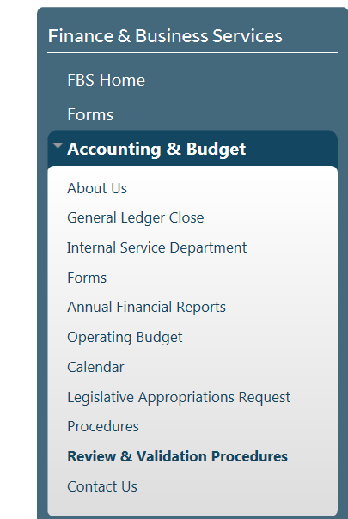

**Print the following:**

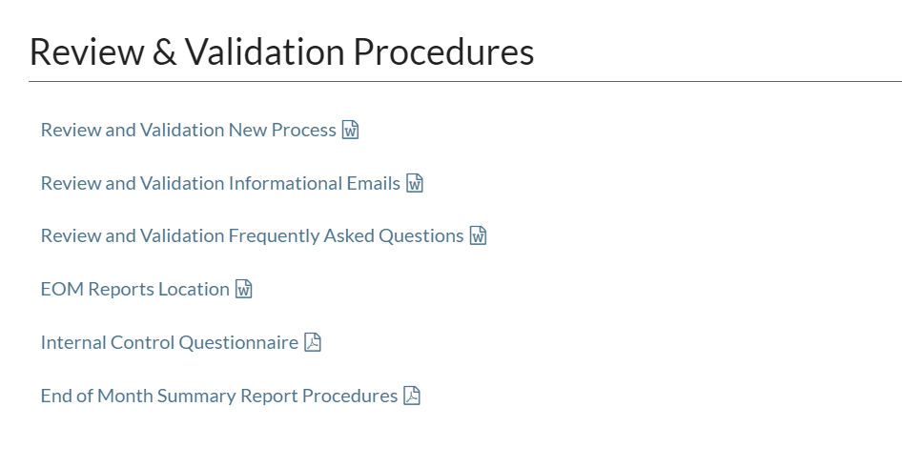

End of the Month Summary (EOM) Reports are located on the following drive:

\\NASPSNFS.UTH.TMC.EDU\PSOFT\prd_fmssecure\reports drive. This drive must be mapped on your computer before accessing. These reports will allow you to review, print, save and reconcile your area’s EOM (PDF file) as well as pre-encumbrances and encumbrances.

To map the drive, go to:

Start, Computer, “Map Network Drive”

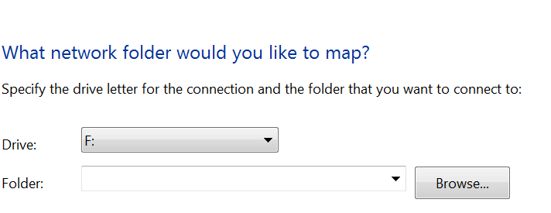

Paste the link above in the “Folder” Field

Click Finish

**Note**: Please pay particular attention to the mapping drive as this will be the drive for your EOM reports. The drive listed above is an example ONLY. Your computer may default to another drive.

**Steps for Monthly Reconciliation**

* Run a Trial Balance for your area using respective instructions indicated above. See Trial Balance example below.

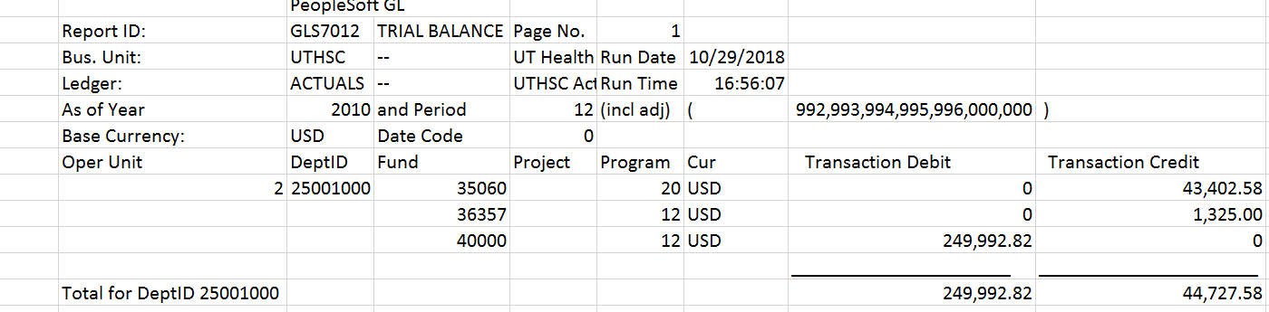

* Run the Ledger Activity Report out of FMS in order to review/to reconcile monthly activity detail.

The path in FMS is: General Ledger\General Reports\Ledger Activity

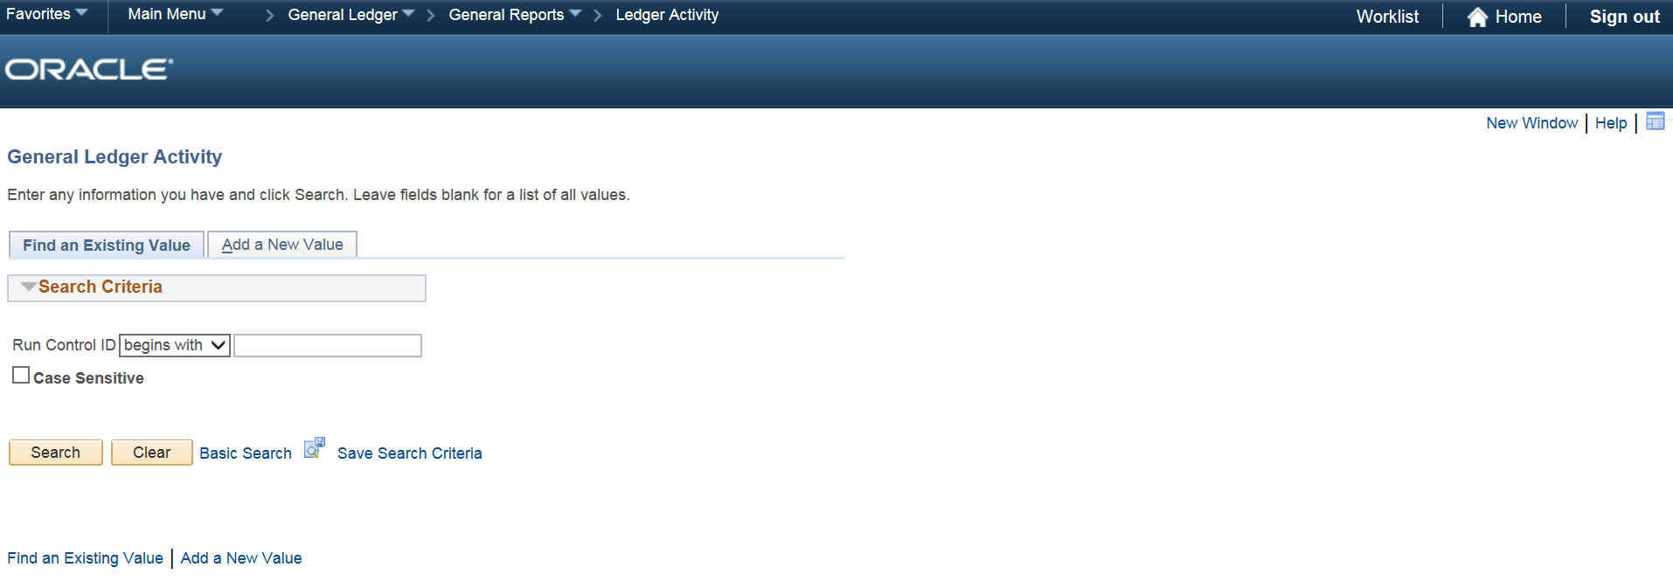

Click on Add A New Value.

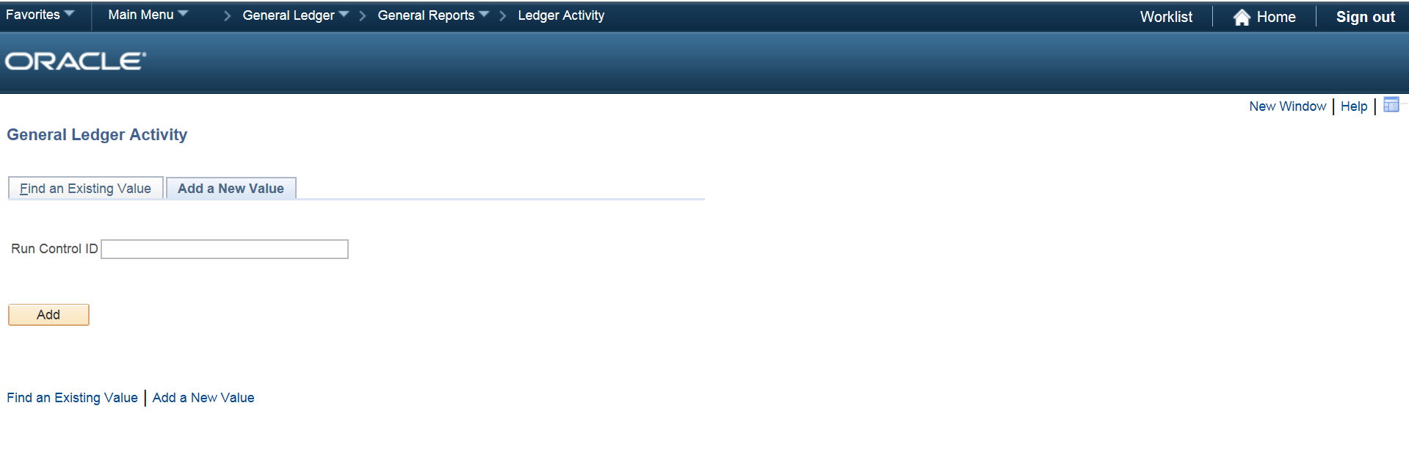

Assign the report a name in the Run Control ID box (no spaces, ex. Ledger_Activity). Click Add.

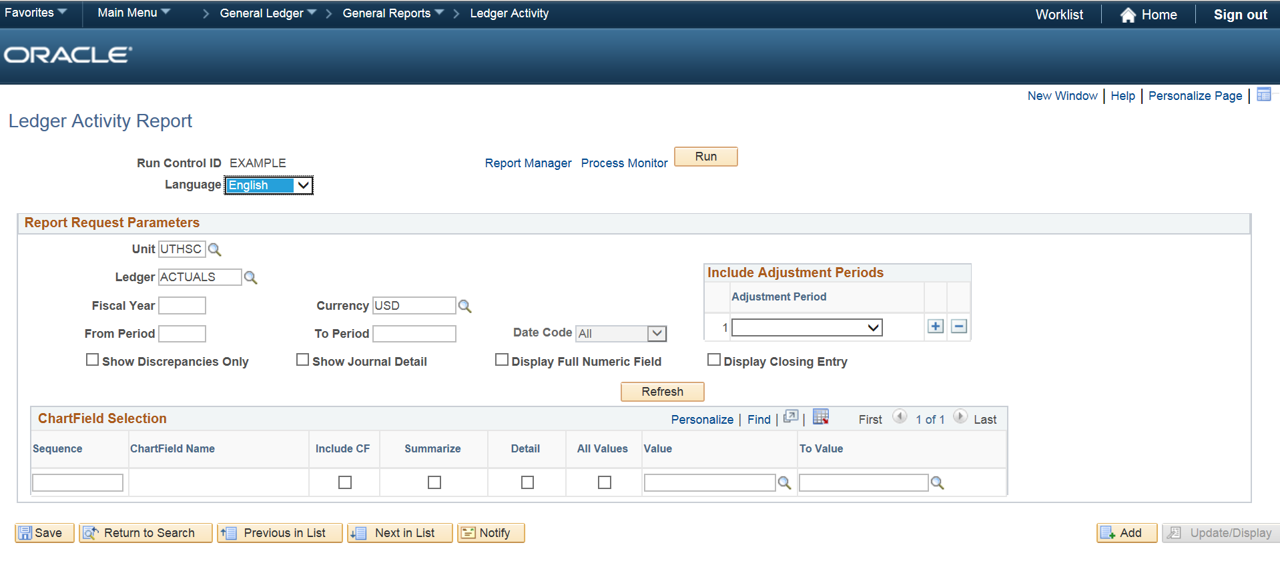

Report Request Parameters:

Unit = UTHSCH

Ledger = ACTUALS

Fiscal Year = 20XX (the year you want the data from)

From Period = XX (the period you want the data from)

To Period = XX (the period you want the data to)

Adjustment Periods = 990 – 998 (click on the plus sign to add each one)

Check Show Journal Detail box.

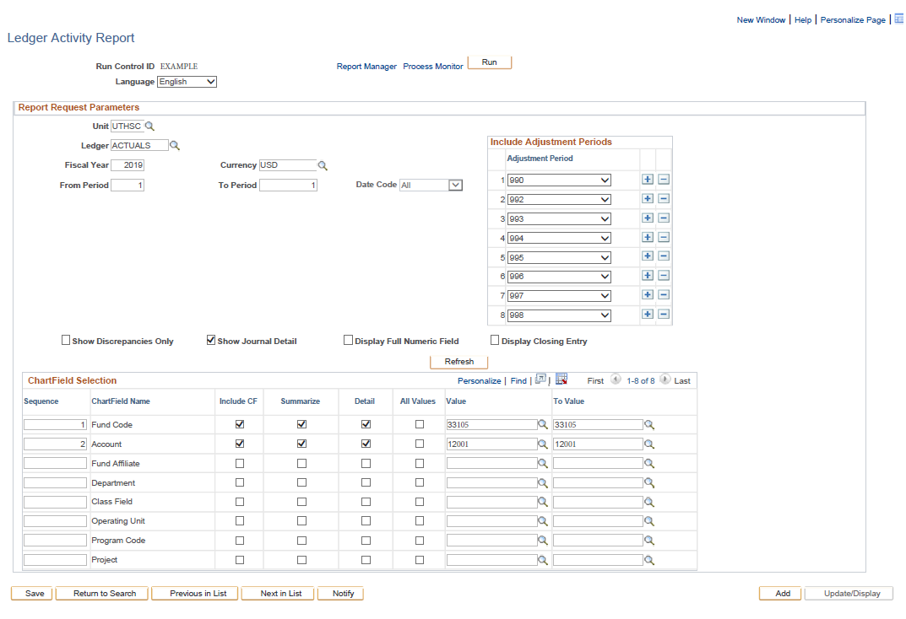

ChartField Selection:

(You may need to click on the Refresh button to see the chartfield selection boxes.)

Sequence: Insert “1” next to “Fund Code” and Insert “2” next to “Account”

Check the following boxes on the rows for the Fund Code and Account:

* Include CF
* Summarize
* Detail

Value/To Value: Enter the first fund code in the Value box and enter the last fund code in the To Value box (please note this will return ALL fund code numbers in that range). If you have breaks in your numerical sequence you will need to run this multiple times. Do the same for the account.

Once this data is entered, click on Run at the top of the page.

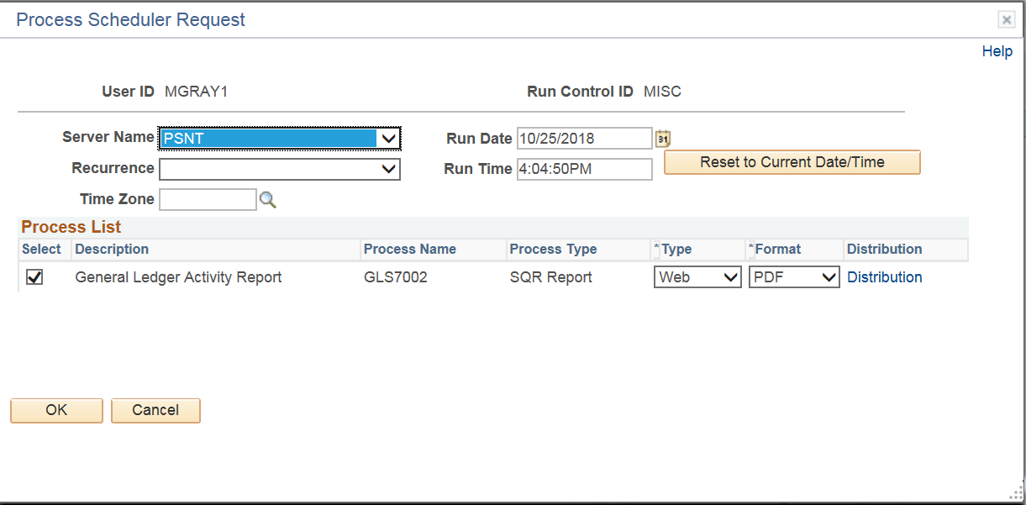

Running the Report:

Server Name = PSNT

Type = WEB

Format = PDF

Click OK.

Click on Process Monitor on the Ledger Activity Report page.

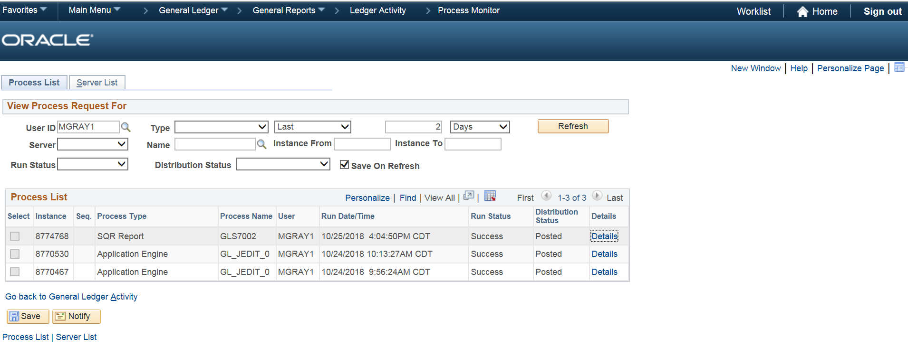

To retrieve the report, click on Details.

Please note: Run Status and Distribution Status must read **Success** and **Posted**, respectively, before you can retrieve the report. This may take a few minutes.

Click on Refresh until the report is ready.

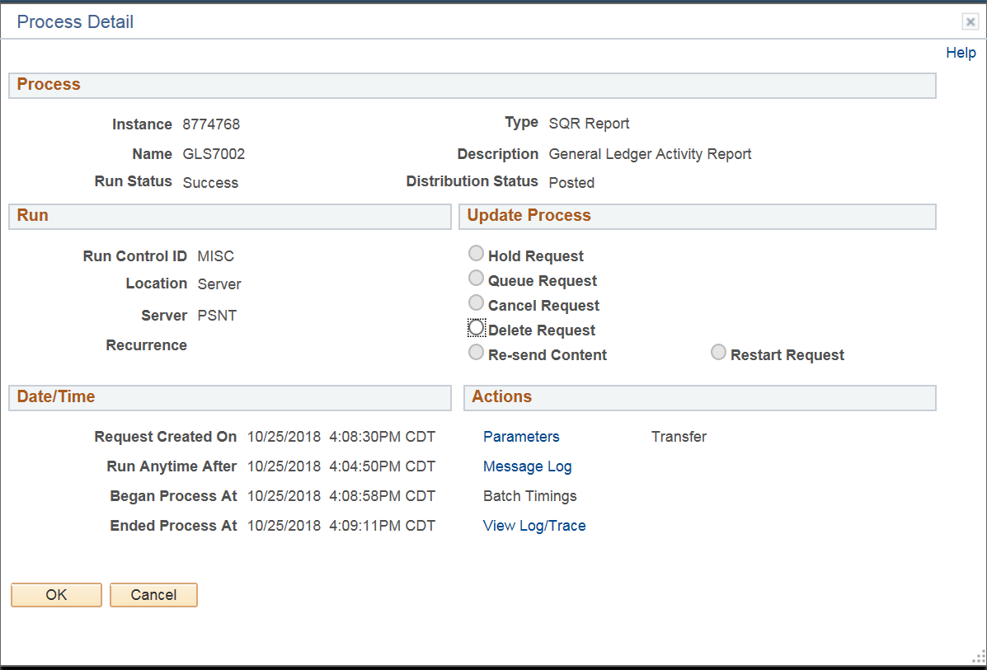

Click on View Log/Trace.

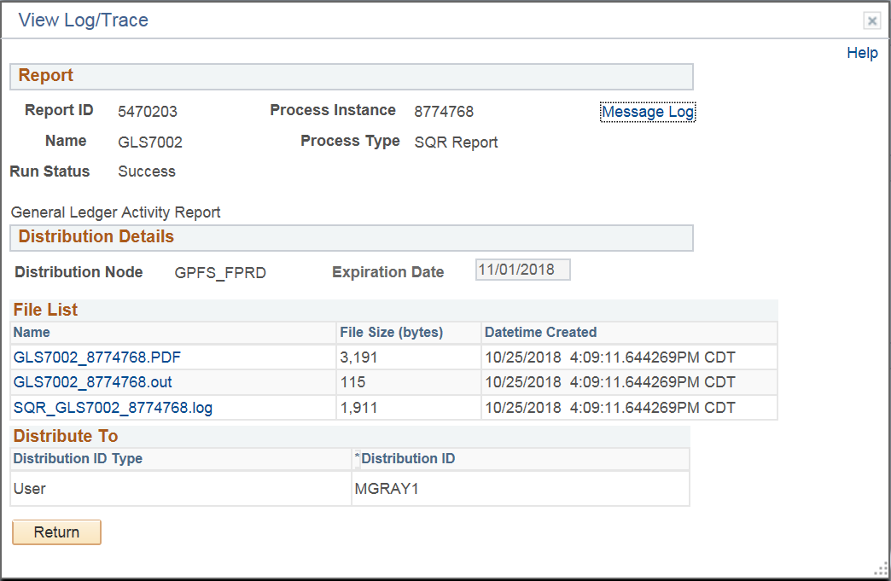

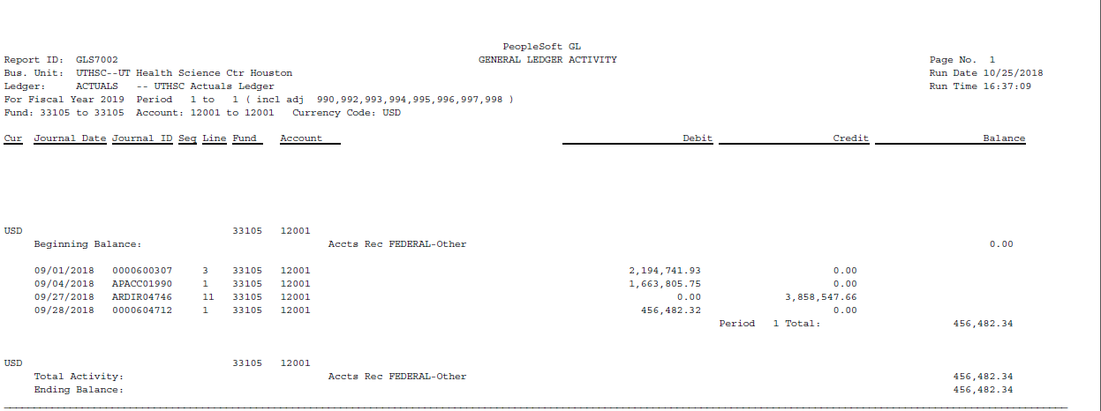

Click on the PDF file and save file.

Reconcile non-payroll activity listed in ledger report to the activity listed in Doc Id Log for the month. This includes both revenue and expenditure transactions. For example, for revenue posted to ledger should reconcile to cash receipts file maintained by your area.

Reconcile payroll data listed in the ledger report to the UT_GL_PAYHIST_BY_DEPT report provided by MMS Office of Administration around the 19th/20th of each month via email (i.e., confirm employees and employees’ salaries are charged appropriately and total salaries and wages reconcile on both reports). Research and take appropriate actions for errors.

Research any non-salary activity listed in the ledger that is not listed on the Doc Id Log. Update log if the transaction was an oversight. Or take appropriate steps to have incorrect expenditures removed (if and when applicable).

* Review Purchase Orders (POs), pre-encumbrances and encumbrances activity for non-payroll expenditures. These reports can be found on the secured drive as mentioned above.

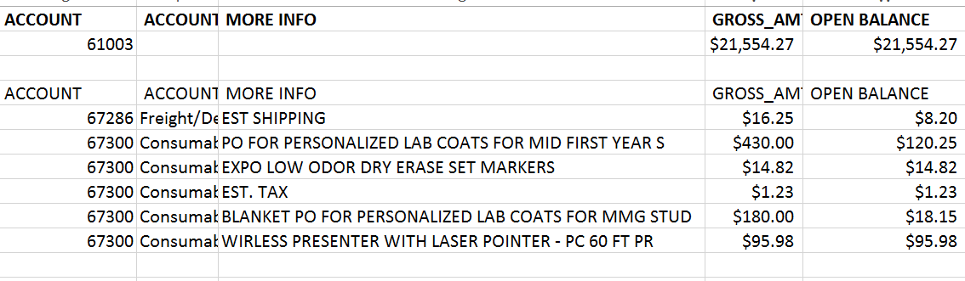

The Gross Amounts shows the total PO amount and the Open Balance is the amount remaining on the PO except for the salary pools. When the salary amounts are shown, it list the remaining FY encumbered salaries.

* All fulfilled POs should be closed once all the vouchers applied against the PO have been paid in FMS. (Submit request to close PO to purchasingservices@uth.tmc.edu)

Once the account reconciliation review process is completed, fill out the checklist below and keep it on file.

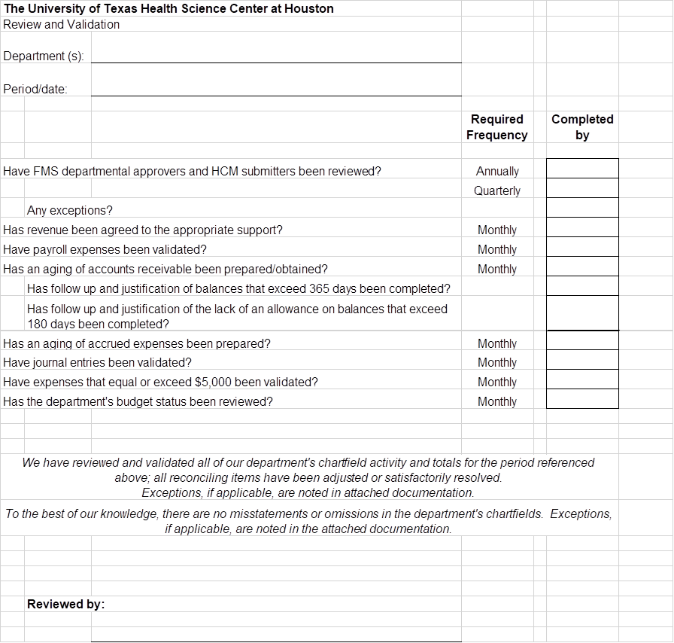

**Budget Overview**

This section allows you to review the overall budget status and drill down to individual budget details and transaction activity.

The path in FMS is: Commitment Control\Review Budget Activities\Budget Overview

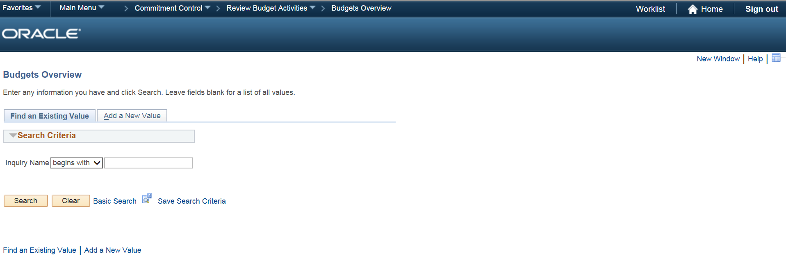

Click on Add A New Value.

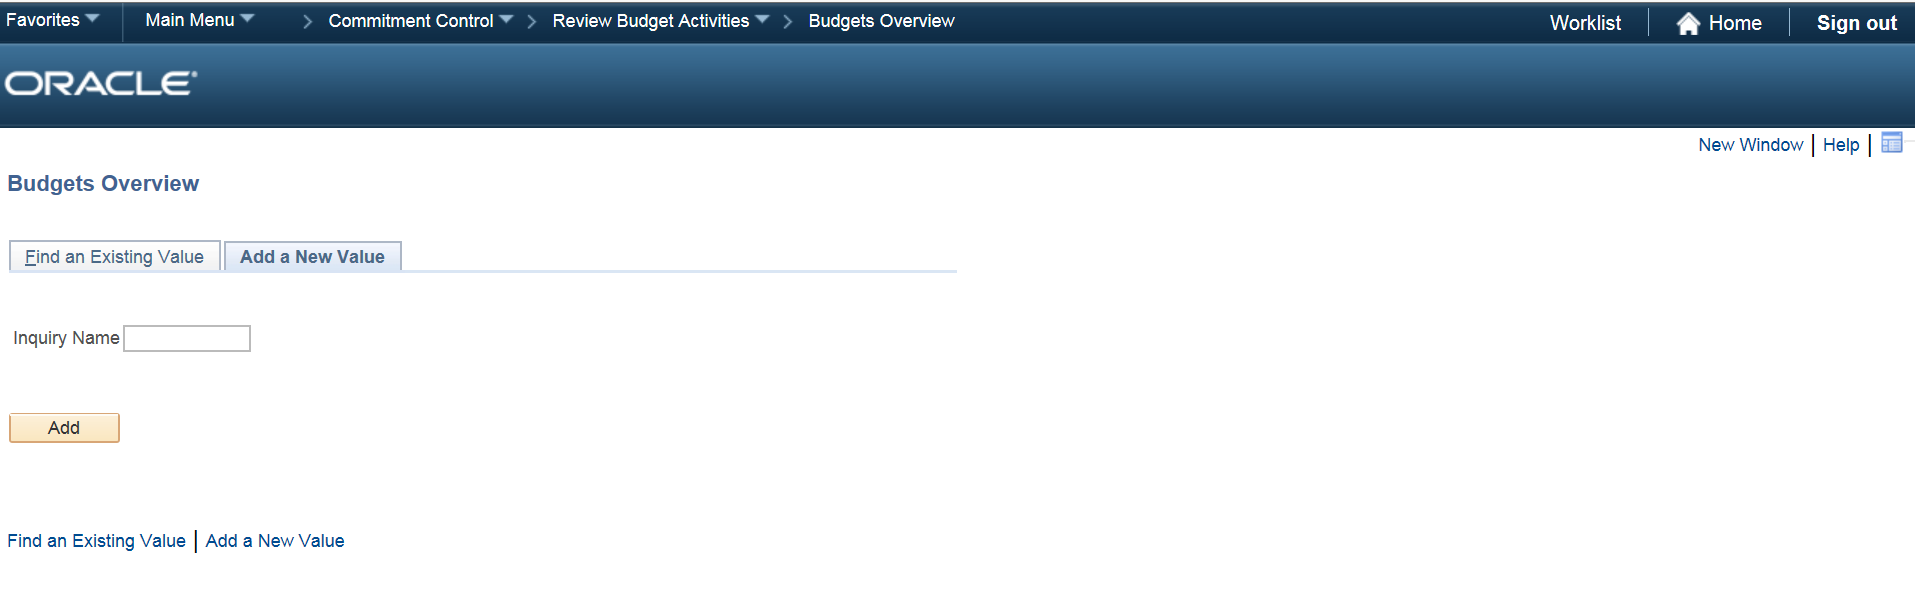

Assign the report a name in the Inquiry Name box (no spaces, ex. Budget_FMS). Click Add.

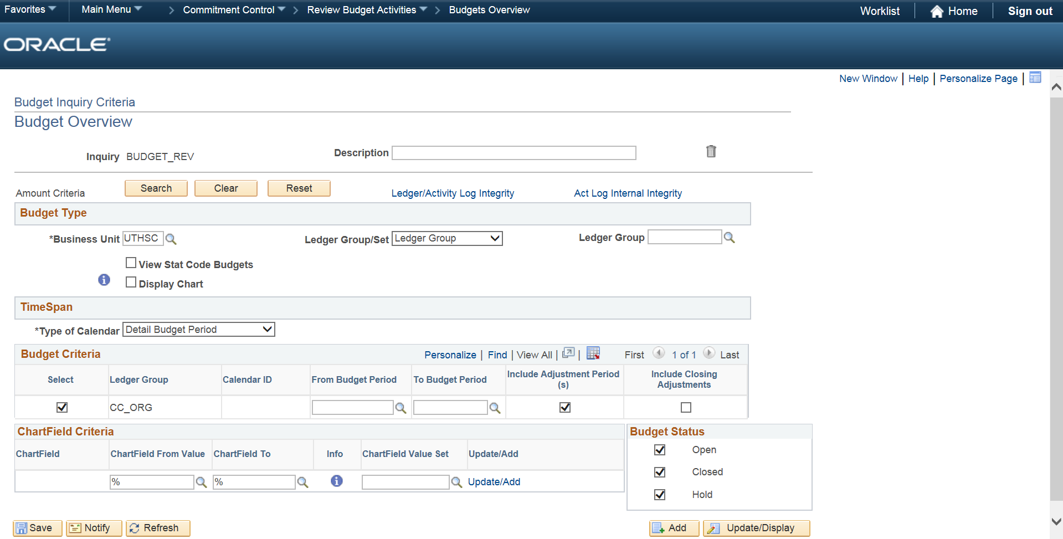

To review revenue activity, click on the looking glass next to box for Ledger Group and select CC_REV.

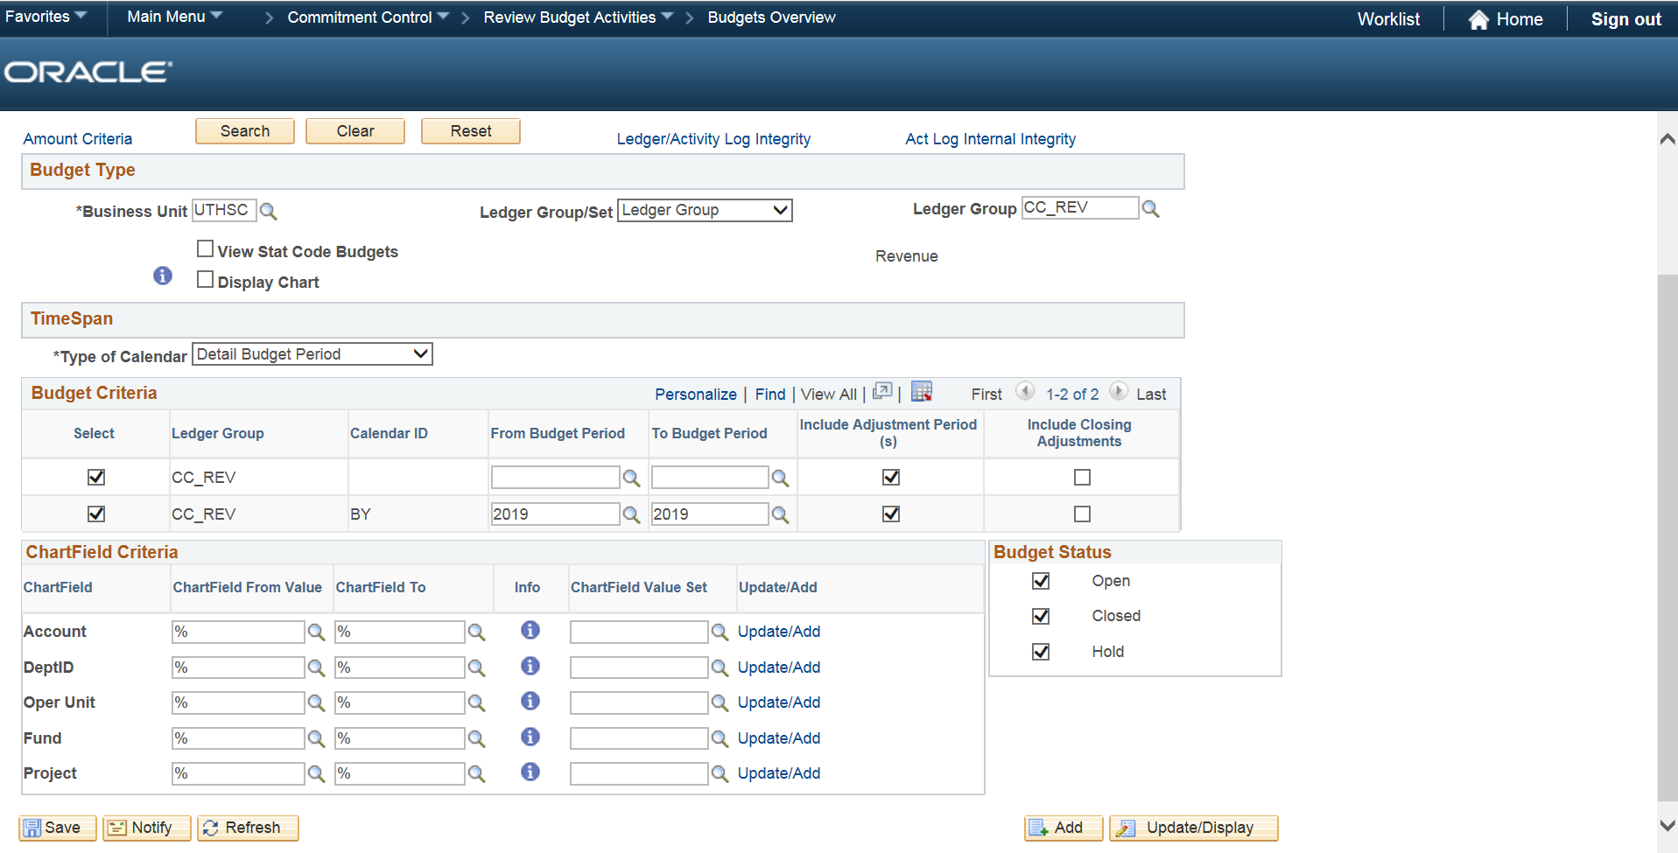

Uncheck the boxes on the first line under Budget Criteria in order to view the current year’s activity only. Make sure the boxes are checked on the second line and the current year is listed in the From Budget Period and To Budget Period boxes.

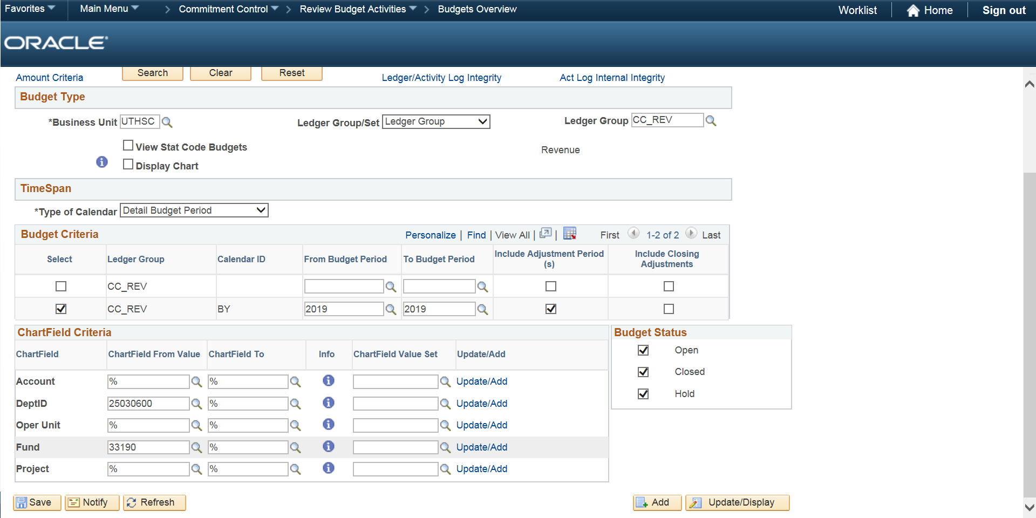

Under Chartfield Criteria, enter the chartfield information you would like to view. For example, if you want to view the revenue activity for chartfield 02 25030600 33090, enter 25030600 in the DeptID box and 33190 in the Fund box. If you want to view all the chartfields related to just fund 33190, just enter 33190 in the Fund box. If you want to view all the funds related to department ID 25030600, just enter 25030600 in the Fund box.

Once the criteria has been entered, click on Search.

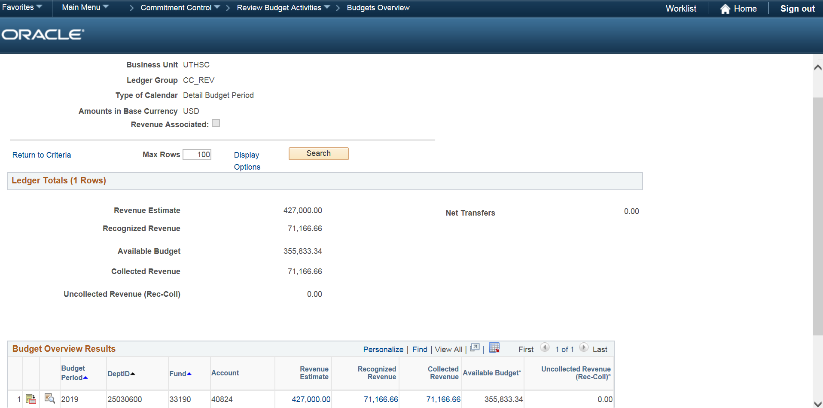

Revenue Estimate – This is the amount budgeted on the chartfield for the fiscal year.

Recognized Revenue – This is amount recognized/entered in the general ledger for the fiscal year.

To review expenditure activity and the available spending authority for a chartfield, click on the looking glass next to box for Ledger Group and select CC_SUM.

Follow the same instructions for CC_REV.

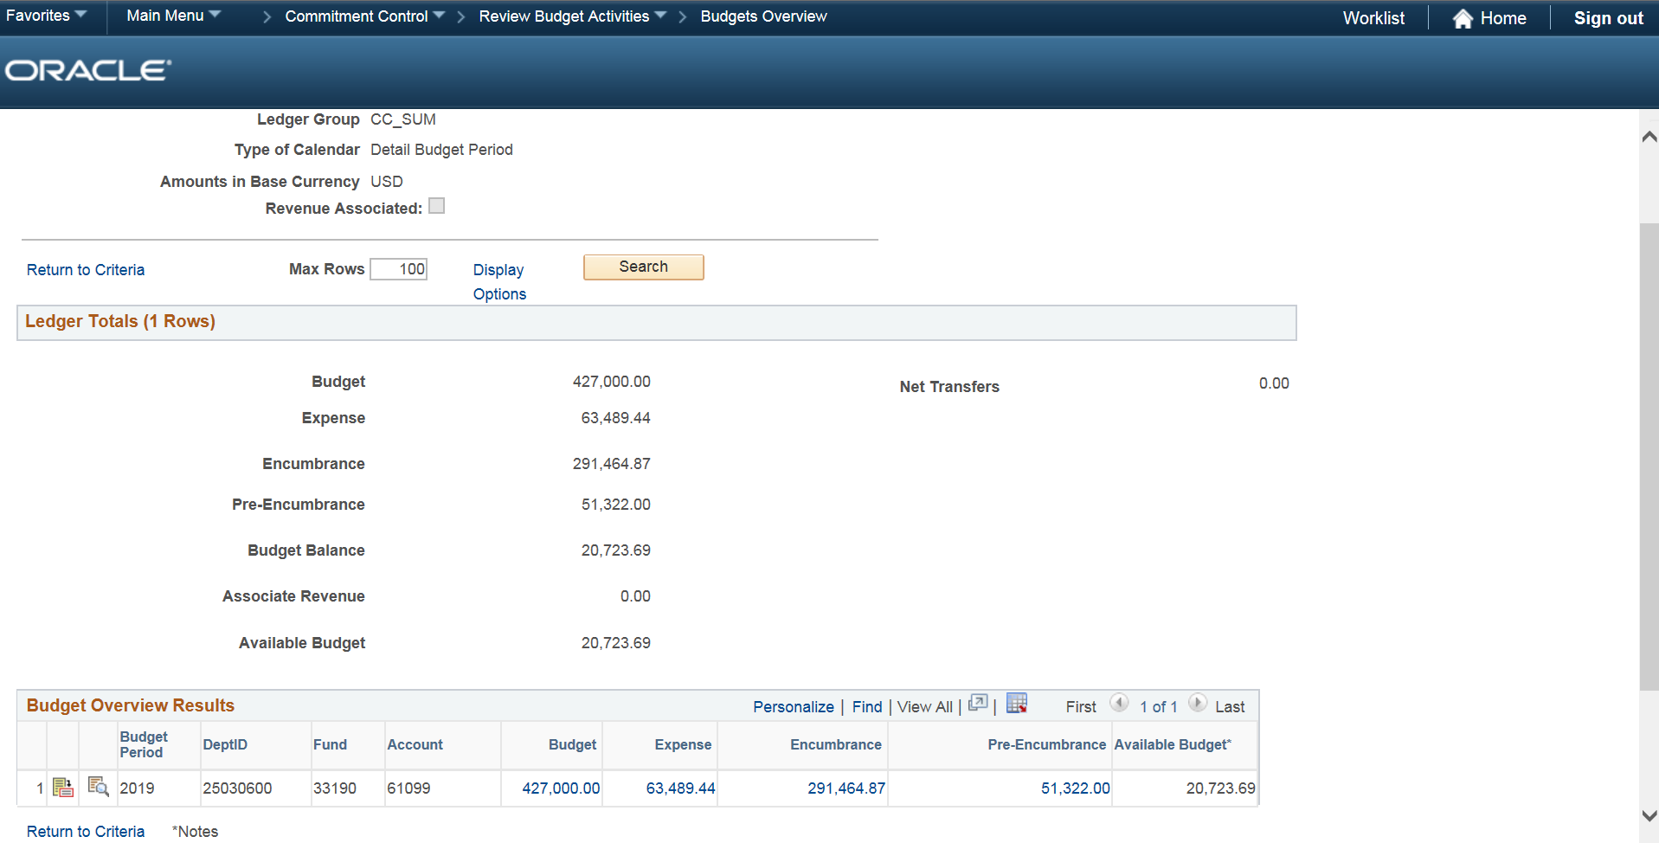

Budget – This is the amount budgeted on the chartfield for the fiscal year.

Expense – This is amount recognized/entered in the general ledger for the fiscal year.

Available Budget – This is the amount available on the chartfield for the department to spend.

**Budget Journal & Journal Entry Requests**

Fill out the Budget Journal & GL Journal Entry Request Form located on the MMS Finance website.

Submit your requests to the MMS Finance Office via email.

