Supplemental Figure 1: Comparison of plasma cytokine/chemokine levels in SSc patients not treated with immunosuppressive agents vs. control subjects
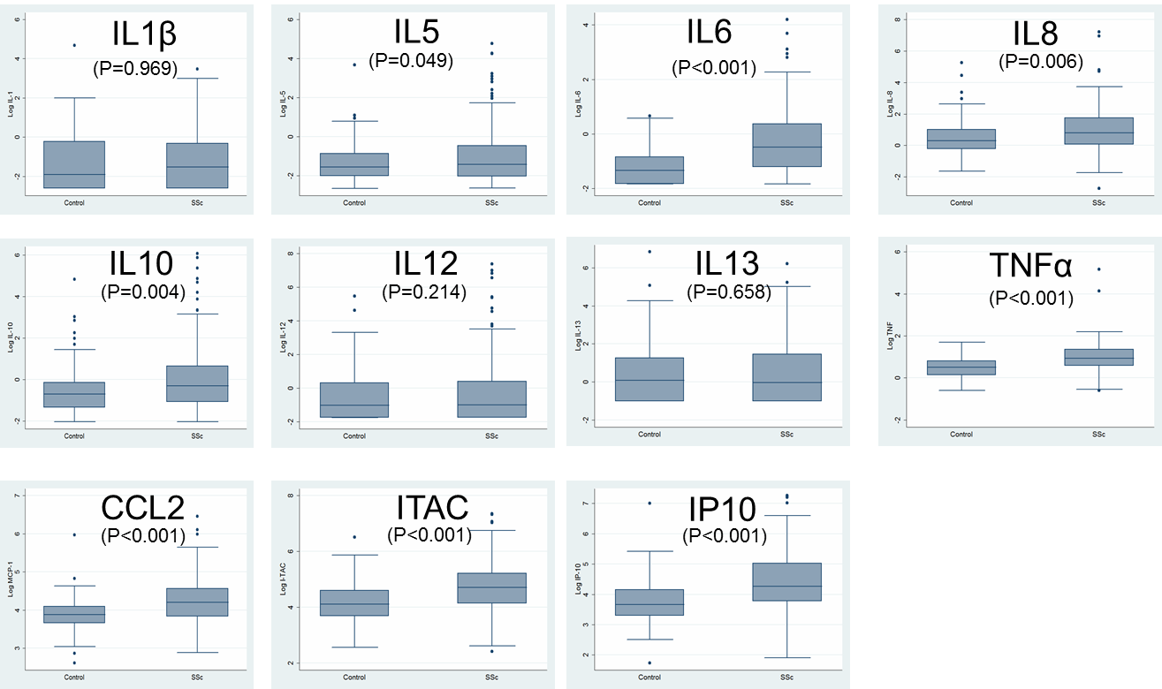

Supplemental Table 1: Study Subject characteristics.
Characteristics |  | GENISOS Cohort  SSC (n=266) (%) | Control Subjects  (n=97) (%) | Canadian Cohort  SSc (n=171) (%)
Female gender |  | 221 (83%) | 78 (80%) | 142 (83%)
Age at first study visit, mean ±SD years |  | 48.6 ±13.5 | 48 ±12.7 | 53.1 ±11.9
Diffuse cutaneous involvement |  | 156 (59%) |  | 66 (39%)
Disease duration, mean ±SD years |  | 2.5 ±1.6 |  | 2.2 ±1.2
Ethnicity | White | 125 (47%) | 48 (49%) | 147 (86%)
 | African American | 54 (20%) | 17 (18%) | 3 (2%)
 | Latino | 77 (29%) | 27 (29%) | 2 (1%)
 | Others | 10 (4%)
Antibodies | Anti-centromere antibody | 32 (12%) |  | 46 (27%)
 | Anti-topoisomerase I antibody | 49 (18%) |  | 32 (19%)
 | Anti-RNA polymerase III antibody | 61 (23%) |  | 19 (11%)
 | Anti-U1 RNP antibody | 30 (11%) |  | 8 (5%)
Immunosuppression |  | 82 (32%) |  | 49 (29%)

Supplemental Table 2: Comparison of plasma cytokine levels between SSc patients vs controls in GENOSIS Cohort
Cytokine/  Chemokine | b | 95% CI | p-value | Subgroup analysis for patients not treated with immunosuppressive agents  b 95% CI p-value
IL-1β | -0.021 | (-0.350; 0.309) | 0.903 | -0.007 | (-0.366; 0.352) | 0.969
IL5 | -0.243 | (-0.548; 0.061) | 0.117 | -0.341 | (-0.680; -0.002) | 0.049
IL6 | -0.893 | (-1.130; -0.656) | <0.001 | -0.938 | (-1.185; -0.691) | <0.001
IL8 | -0.491 | (-0.814; -0.168) | 0.003 | -0.476 | (-0.817; -0.135) | 0.006
IL10 | -0.540 | (-0.877; -0.202) | 0.002 | -0.556 | (-0.935; -0.178) | 0.004
IL12 | -0.186 | (-0.603; 0.232) | 0.382 | -0.297 | (-0.767; 0.172) | 0.214
IL13 | 0.068 | (-0.296; 0.433) | 0.713 | -0.092 | (-0.503; 0.318) | 0.658
TNF-α | -0.446 | (-0.612; 0.280) | <0.001 | -0.468 | (-0.648; -0.286) | <0.001
CCL2 | -0.393 | (-0.522; -0.265) | <0.001 | -0.351 | (-0.482; -0.220) | <0.001
ITAC | -0.689 | (-0.902; -0.475) | <0.001 | -0.601 | (-0.822; -0.380) | <0.001
IP10 | -0.760 | (-0.987; -0.533) | <0.001 | -0.699 | (-0.927; -0.472) | <0.001
* Adjusted for age, gender, and ethnicity at enrollment.

Supplemental Table 3. Correlation (r) between cytokines in GENOSIS cohort
 | IL5 | IL10 | IL12 | CCL2
IL5 | 1.0000 | 0.8269 | 0.8738 | 0.0251
IL10 |  | 1.0000 | 0.8333 | 0.0509
IL12 |  |  | 1.0000 | 0.0119
CCL2 |  |  |  | 1.0000

Supplemental Table 4: Longitudinal analysis of predictive significance of CCL-2 and IL-10 for mRSS in dcSSc patients in the GENOSIS cohort *
Cytokine/Chemokine | Main effect of cytokine  b 95% CI p -value |  |  | Interaction term between baseline cytokine and follow up-time  b 95% CI p -value
CCL2 | 1.15 | (-2.02; 4.31) | 0.477 | -0.38 | (-1.07; 0.31) | 0.280
IL10 | 0.37 | (-0.73; 1.47) | 0.509 | -0.16 | (-0.45; 0.13) | 0.290
* Adjusted for age at enrollment and gender.

Supplemental Table 5: Longitudinal analysis of predictive significance of CCL-2, IL-10 and IL-6 for the decline of FVC% in the CSRG cohort *
Cytokine/Chemokine | Main effect of cytokine  b 95% CI p -value |  |  | Interaction term between baseline cytokine and follow up-time  b 95% CI p -value
CCL2 | -4.53 | (-8.56; -0.49) | 0.028 | -0.58 | (-1.14; -0.03) | 0.038
IL10 | -4.94 | (-8.92; -0.96) | 0.015 | -0.06 | (-0.75; 0.63) | 0.859
IL6 | -6.04 | (-10.06; -2.02) | 0.003 | -0.58 | (-1.21; 0.04) | 0.068
* Adjusted for age at enrollment and gender.

Supplemental Table 6: Immunosuppressive treatment at the baseline visit and follow-up time in the GENOSIS cohort*
Treatment | Baseline (%) |  | Follow-up (%) #
Prednisone >5mg | 59 | (22.2%) | 29 | (13.2%)
Azathioprine | 6 | (2.3%) | 4 | (1.8%)
Methotrexate | 25 | (9.4%) | 22 | (10.0%)
MMF | 4 | (1.5%) | 11 | (5 %)
Cytoxan | 8 | (3.0%) | 24 | (10.9%)
Immunosup | 43 | (16.2%) | 54 | (24.5%)
Immunosup/pre | 82 | (30.8%) | 70 | (31.8%)

* Due to logistical reasons, only patients enrolled before 2010 were included in the present study.
# Medication regimen during the first year of follow-up.

