
Texas Educator’s Academies Collaborative for Health Professions – Southeast
2024 TEACH-S Educational Symposium

Date: Friday, May 3, 2024
Time: 7:30 a.m. - 3:30 p.m.
Location: Health Education Center (HEC) at the University of Texas Medical Branch in Galveston, Texas
This is an in-person event; no virtual option is available.
Conference Theme: Adapting Teaching and Learning in the Digital Era
Website: https://www.utmb.edu/amt/events/symposium-2024/home

Call for Proposals
Proposals accepted between January 5 and February 9, 2024

Proposals can be submitted for the following categories: Abstracts, Workshops, Small Group Discussions, and a Special Student Panel. Please note: Individuals may be the lead author on no more than two conference submissions. Submission of work previously presented at educational conferences is encouraged.

ABSTRACTS:
Abstracts describing educational innovations, educational research, or quality initiatives in education are welcome. Accepted abstracts will be presented as posters or short oral presentations.
Abstracts should describe work that has been implemented and results/outcomes information must be available. Use the following headers within the abstract:
For research abstracts: Introduction, Methods, Results, Conclusions
For innovation/quality initiatives: Introduction, Project Description, Outcomes, Conclusions
References (up to 5) may be included
Abstracts are limited to 350 words; title, authors, and references are not included in the word count; however, the title has a max of 10 words.

Submit an Abstract here: https://forms.office.com/r/kwiDYqhQhT

SMALL GROUP DISCUSSIONS:
Small Group Discussion Sessions are intended to address contemporary topics that impact our roles in education. These sessions may have a maximum of three leaders/facilitators. Discussion sessions are 60 minutes. Recommended format is a brief (~ 10 minute) overview of the topic followed by a facilitated discussion with the attendees. Prompt questions are helpful to guide the attendees in the discussion. Use the following format when submitting a proposal for a discussion session:
Topic: Provide a brief background on the topic and its relevance to healthcare education
Prompt questions: Include 2-3 questions that can be used to facilitate the discussion.
Discussions may have up to five facilitators. Small Group Discussion proposals are limited to 300 words; title, authors and references are not included in the word count; however, the title has a max of 10 words.

Submit a Small Group Discussion here: https://forms.office.com/r/nkDgtq3xw8

WORKSHOPS:
Workshops are 60 minutes and should highlight active learning. Submissions must emphasize how the facilitators plan to engage attendees in active learning for the majority of the workshop period. Submissions must clearly state the workshop objectives and how the planned activities will engage attendees to address these objectives. Workshop submissions must follow the following format:
Background: Provide a brief overview of the topic and its relevance to healthcare education
Workshop objectives: Clearly state the objectives of the workshop
Timeline: Outline a timeline with a brief description of active learning techniques to be used
Workshops may have up to five facilitators. Proposals are limited to 300 words; title, authors, and references are not included in the word count; however, the title has a max of 10 words.

Submit a Workshop here: https://forms.office.com/r/6bbKwgDBjC

SPECIAL STUDENT PANELIST OPPORTUNITY:
During the afternoon of the conference, there will be an hour-long student panel facilitated by a moderator. We are asking students from all schools to apply; you will be notified if selected to serve on the panel. Submissions should include a paragraph on what perspective you would bring to the panel. We want to know how students learn best especially in a time where there is a wealth of available digital resources. Students of all training levels are encouraged to apply. A limited number of students will be selected.

Submit to be a Student Panelist here: https://forms.office.com/r/18QkJFxWzc

PLEASE NOTE: the last date for proposal submissions is February 9th, 2024 at 11:59 pm Central time. No late submissions will be accepted.

Once you successfully submit your proposal, you will see the image below. You can also click on “Save my response” which takes you to your Microsoft Forms page. Then, by clicking on “Filled Forms,” you can locate your answers provided during completion.
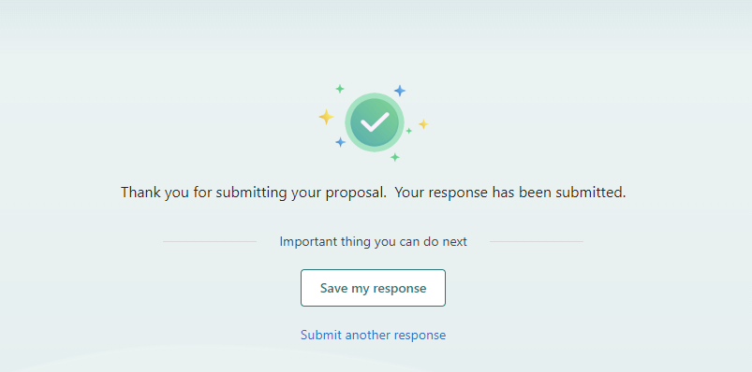

If you have any questions about the conference submission or formatting guidelines, please contact Karen Szauter kszauter@utmb.edu and/or Holly West hawest@utmb.edu. Please include TEACH-S CONFERENCE QUESTION in the message line of your email.

