 | Otorhinolaryngology- Head & Neck Surgery | 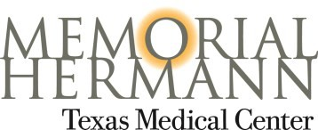
713-486-5000 (voice) | 713-383-1410 (fax) | www.ut-ent.org
UTHEALTH AUDIOLOGY REQUEST FORM
Instructions: Please provide all available information and then fax the form back to us at 713-383-1410.

Name |  |  | DOB |  | Date
Other contact/parent |  | UTP IDX# |  | MH MRN
Telephone
H | W |  | M
Insurance company (primary)
ID# | Group # | Telephone |  | Fax
Insurance company (secondary)
ID# | Group # | Telephone |  | Fax
Procedure(s) Requested
- Vertigo/Dizziness Evaluation (Videonystagmography [VNG])
- Diagnostic Hearing Evaluation
- Digital Hearing Aid Evaluation
- Cochlear Implant Candidacy and/or BAHA Evaluation
- Treatment for Vertigo/Dizziness(Epley Maneuver)
- Auditory Brainstem Responses (ABR)
- Sedated Auditory Brainstem Response (ABR)
- Electrocochleography (EcoG) for Endolympatic Hydrops
- Tinnitus Evaluation & Management
- Electroneurography for Facial nerve monitoring
- Newborn hearing screening failure
Patient History
Requesting Physician
Name |  |  | Date
Address
Street | City |  | State |  | Zip
Telephone |  | Fax

