713-486-5000
University of Te xas
Medical School at Houston Depar tment of
Otorhinolar yngolog y
Patient Information Series
www.ut-ent.org www.ut-ent.net
Home Epley Maneuver

Document ID: Home Epley Maneuver (Rev. 2011-02-22)

The Epley maneuver can be done at home. We often recommend the home Epley to our patients who have a clear diagnosis. This procedure seems to be even more effective than the in-office procedure, perhaps because it is repeated every night for a week.
The method (for the left side) is performed as shown on the figure . One stays in each of the supine (lying down) positions for 30 seconds, and in the sitting upright position (top) for 1 minute. Thus, once cycle takes 2 1/2 minutes. Typ- ically 3 cycles are performed just prior to going to sleep. It is best to do them at night rather than in the morning or midday, as if one becomes dizzy following the exercises, then it can resolve while one is sleeping. The mirror image of this procedure is used for the right ear.
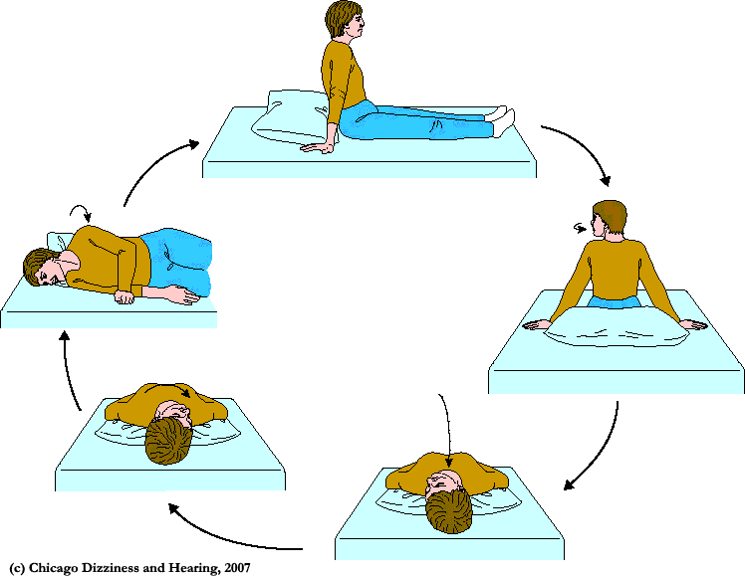
There are several problems with the "do it yourself" method. If the diagnosis of BPPV has not been confirmed, one may be attempting to treat another condi- tion (such as a brain tumor or stroke) with positional exercises -- this is unlike- ly to be successful and may delay proper treatment. A second problem is that the home-Epley requires knowledge of the "bad" side. Sometimes this can be tricky to establish. Complications such as conversion to another canal can oc- cur during the Epley maneuver, which are better handled in a doctor's office than at home. Finally, occasionally during the Epley maneuver neurological symptoms are provoked due to compression of the vertebral arteries.

