Texas Sinus Institute Texas Skull Base Physicians
713-486-5000 (voice) | 713-383-1410 (fax) | www.ent4.me
CONSULTATION REQUEST FORM
Instructions: Please provide all available information and then fax the form back to us at 713-383-1410.

Name |  |  |  | DOB |  | Date
Other contact/parent |  |  | UTP IDX# |  | MH MRN
Telephone
H |  | W |  | M
Insurance company (primary)
ID# |  | Group # | Telephone |  | Fax
Insurance company (secondary)
ID# |  | Group # | Telephone |  | Fax
Appointment
- Appointment scheduled. (Please specify date.) |  |  | - Please call the patient to schedule the appointment.
Surgeon
- Martin J. Citardi, MD |  | - Amber Luong, MD, PhD |  | - William Yao, MD
Specialty Area
 | - Sinus |  |  | - Skull Base
Patient History (Reason for Consult)
Imaging
- Yes  - No | Details
Requesting Physician
Name |  |  |  | Date
Address
Street |  | City |  | State |  | Zip
Telephone |  |  | Fax

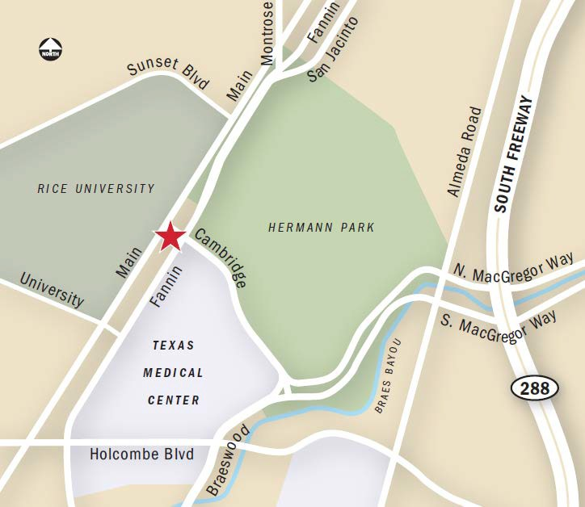

Texas Sinus Institute Texas Skull Base Physicians
713-486-5000 (voice) | 713-383-1410 (fax) | www.ent4.me

 | Location
Physicians
Martin J. Citardi, MD
Professor & Chair
Amber Luong, MD, PhD
Associate Professor
William Yao, MD
Assistant Professor
6400 Fannin Street
Suite 2700
Houston, TX 77030

713-486-5000 (v)
713-383-1410 (f)
Texas Sinus Institute  www.texassinus.org | Texas Skull Base Physicians  www.texasskullbase.org

