Business Card Order Form

Business Card Details
Flat: 3" x 2.5"
Stock: 100# Cougar Opaque White Cover Double sided

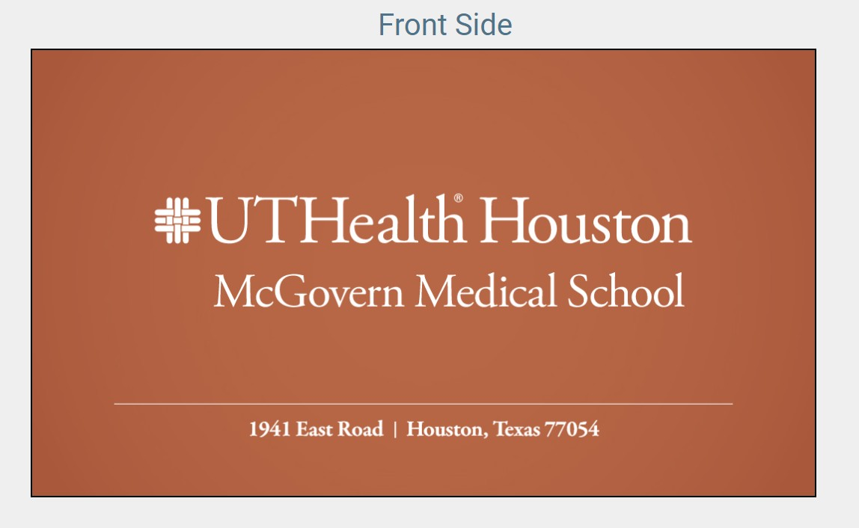Example

Order Details:
Instructions: Please complete all fields. Please note that the highlighted fields are required to complete your order.

Administrative Contact:
Funding Source:

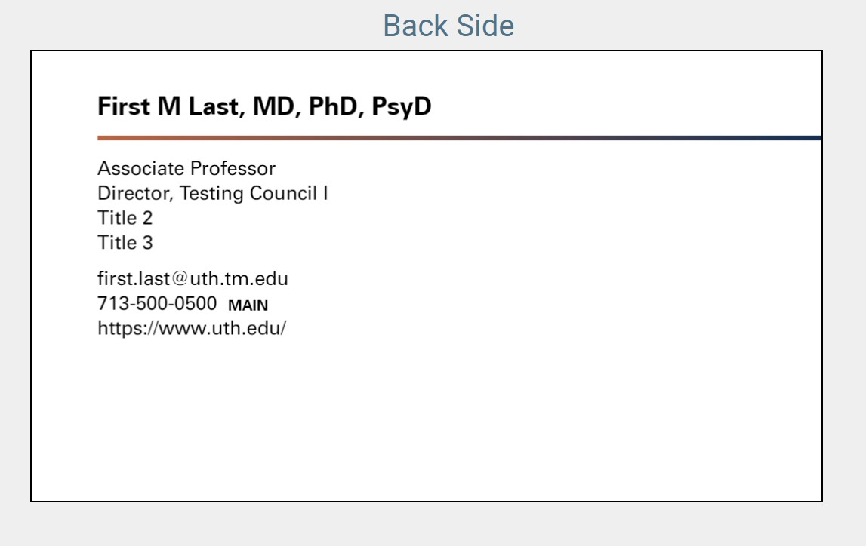Front Side

Address (select one):

1941 East Road 6431 Fannin Street

Houston, TX 77054 Houston, TX 77030

Back Side
First Name:

Primary Title:

Middle Initial: Title 1:

Title 2:
Last Name:

Credentials: Title 3:

Direct phone number: Cell phone number:
Email:
Main phone number:
Secondary Title:
Title Line:
Quantity:

250 500 1000

Web/URL:

