Copy Code Request Form

Full Name:

Login User ID (UT Credentials Username):

Employee ID (Found in Self-Service):

UT Badge Number (See Below for Instructions):

Instructions on finding UT Badge Number: Most UTH Badge Numbers are 7 or 8 digits and are found on the back of your badge in the lower right, beneath the magnetic strip. The Badge Number is the portion that does not contain a hyphen, letter or other non-numeric character. See the below examples for additional details.

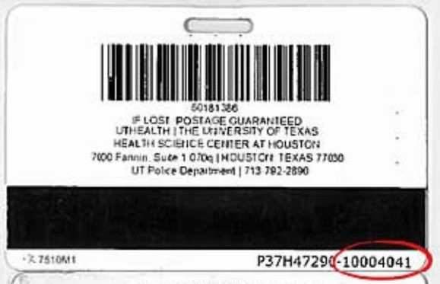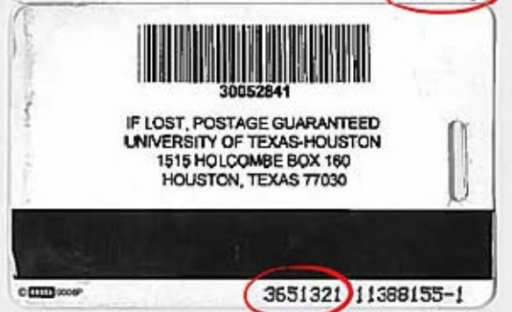

PO Number:
1. Do you already have a Copy Code PO for your group?
Select One.

2. If not, then please provide a CFS so that we can set up a PO then complete the "Request to Add" section. Once a PO is created then we can use the information below to create the copy code.

CFS:

Request to Add/Delete Copy Code
I want to add a Copy Code.  Code to be deleted (if deleting a copy code) : Full Name of person being added or deleted: Employee ID (found in Self-Service):  Login User ID (UTH login credentials):  UT Badge Number |  | I want to delete a Copy Code.
PO Number:  Project Number (from PO CFS): | Department ID:

