VIRTUAL CARD (VCARD) REQUESTS

AGENDA

- vCard Summary
- vCard Transaction Types
- Request a vCard Transaction
- vCard Transaction Approval Process
- Transaction
- vCard Request Form
- Delivery
- List of Restricted Items

VCARD SUMMARY

- vCard is a Virtual Card that replaces the Buycard.
- Single-use Card # for the Requested Merchant.
- Requests must be submitted for approval prior to your transaction. Please allow 7-14 business days for the approval process.

VCARD TRANSACTION TYPES

- Transactions made via Internet or Phone
- Internet Transaction with Recurring Charges
- Registration for Conferences, but RTA must be pre-approved

Please note that the University prefers that we use one of the other transaction types to complete transactions. Please consider using a PO or Non-PO before opting to use the vCard.

REQUEST A VCARD TRANSACTION

- Email Ms.PsychiatryProcurement@uth.tmc.edu with the following details:
  - Completed vCard Request Form with:
    - CFS;
    - Preferred method for completing your transaction
    - Justification for using a vCard vs. a PO or Non-PO

VCARD TRANSACTION APPROVAL PROCESS

Requestor submits vCard Request to Psy Procurement

We recommend allowing
Transaction is completed via Requestor’s preferred method

Psy Procurement acquires DMO Signature

business days to complete the approval process.

Psy Procurement notifies Requestor of approval to complete transaction

Psy Procurement Enters Request in Coupa

Once approved, vCard details are generated and available for view in Coupa

Request proceeds through 5-levels of approval in Coupa

TRANSACTION

There are two options for completing this transaction.
    - You will provide the vCard holder with your login details, including username and password, to complete the transaction on your behalf.
    - Psychiatry Procurement will provide you with the one-time vCard information so that you can complete the transaction.You will provide the receipt to the vCard holder within 24 hours of completing the transaction.
You will need to communicate your preferred option on the vCard Request Form.

VCARD REQUEST FORM

Requestor: Include Physician & Admin Name
Fields highlighted in yellow are required.
Fields in purple text are optional.

Please provide the full CFS.We can add the class code, if needed, and account number.
There are two options for completing your transaction. Please select your preferred course of action.

After your selection, please sign.

Include your reason/need for this
Must be signed by your PI or Mary.

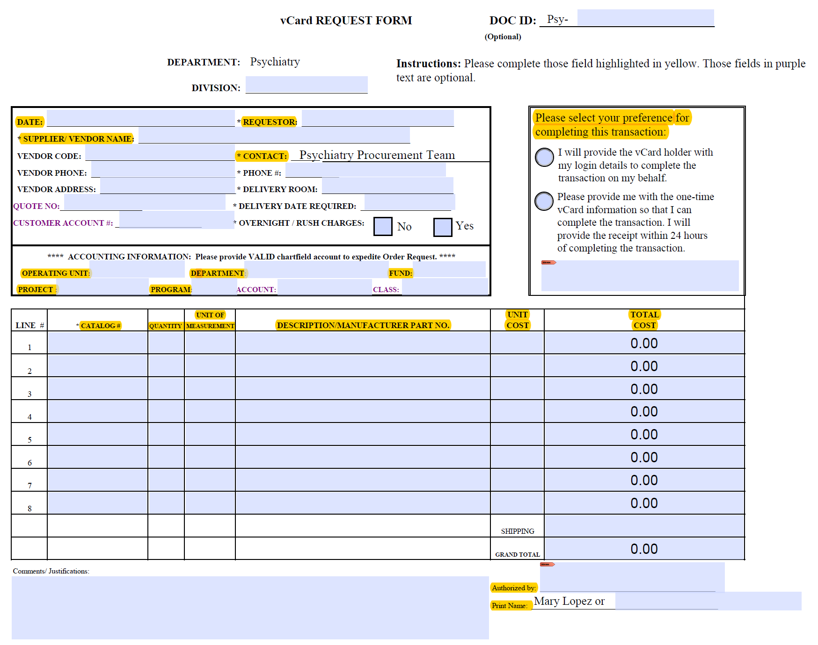purchase. Type your PI’s
name, if needed.

DELIVERY

- Once your transaction is complete, the delivery date will be the shipping date indicated by the vendor when the order is placed.
- Upon receipt of merchandise, please email Ms.PsychiatryProcurement@uth.tmc.edu your packing slip.
- Please ensure that you have emailed Psy Procurement your receipt as well.

LIST OF RESTRICTED ITEMS

- Animals
- Cab and Limousine Service ( no exceptions)
- Cash advances, cash instruments, or cash refunds
- College tuition
- Consulting or personal services (unless under a contract through Purchasing)
- Deposits for retreats, conventions, etc.
- e-bay or on-line auction (including Paypal Suppliers)
- Entertainment
- Flowers - Flower arrangements and plants over $75 are prohibited on the Buycard, those under $75 may be purchased using the Buycard but must be paid on Discretionary Funds
- Food & drink items (only acceptable for departmental coffee and water services which must be paid using Discretionary Funds, no luncheons, parties, etc. allowed)
- Gasoline (except for official UT vehicles)
- Gift Cards
- Gifts – Qualified expenses (see HOOP 2.31) should be reimbursed using a Non-PO voucher and Discretionary Funds
- Hotel Fees
- Memberships
- Notary Public Fees
- Office supplies (only suppliers that are "Active" in PeopleSoft database)
- Parking
- Radioactive material – (Contact Radiation Safety for list of approved suppliers)
- Prescription drugs and/or controlled substances
- U.S. Postage Stamps

