# Behavioral Sciences Imaging Center



### Behavioral and Biomedical Sciences Building 1941 East Road



**Houston, Texas 77054**

***MRI Safety Screening Form***



Date / / Patient Number



Name DOB Male Female Last Name First Name Middle Initial

Height Weight

1. Have you had prior surgery or an operation (e.g., arthroscopy, endoscopy, etc.) of any kind? _ No _ Yes If yes, please indicate the date and type of surgery:

Date / / Type of surgery: Date / / Type of surgery:

1. Have you experienced any problem related to a previous MRI examination or MR procedure? _No _Yes If yes, please describe:
2. Have you had an injury to the eye involving a metallic object or fragment (e.g., metallic slivers,



shavings, foreign body, etc.)? _ No _ Yes

If yes, please describe:

1. Have you ever been injured by a metallic object or foreign body (e.g., BB, bullet, shrapnel, etc.)? _ No _ Yes If yes, please describe:
2. Are you allergic to any medication? _ No _ Yes

If yes, please list:

1. Do you have a history of asthma, allergic reaction, respiratory disease, or reaction to a contrast

medium or dye used for an MRI, CT, or X-ray examination? _ No _ Yes

1. Do you have tattoos, permanent make-up done in the last 2 months? _No _Yes If yes, location?
2. Do you have hair extensions? _No _Yes
3. Do you have any non-removable piercings? _No _Yes

If yes, location?

1. Do you have metal in your body (**pacemaker**, plates, aneurysm clips/coils, deep brain stimulator, pins,

rods, joints, pellets, cochlear implants, etc.)? _No _Yes

If yes, please describe:

1. Have you ever been employed as a farm worker, metal grinder, or welder? _No _Yes
2. Do you wear dentures, partials, braces, or a non-removable orthodontic retainer? _No _Yes
3. Have you ever considered yourself to be claustrophobic? _No _Yes

#### Have you had COVID in the last 2 weeks? _No _Yes

**For female patients:**

1. Are you pregnant or could you possibly be pregnant? _ No _ Yes

# MRI Screening Form

**WARNING**: Certain implants, devices, or objects may be hazardous to you and/or may interfere with the MR procedure (i.e., MRI, MR angiography, functional MRI, MR spectroscopy). Do not enter the MR system room or MR environment if you have any question or concern regarding an implant, device, or object. Consult the MRI Technologist or Radiologist BEFORE entering the MR system room. **The MR system magnet is ALWAYS on.**

## Please indicate if you have any of the following:

#### Yes, No Aneurysm clip(s) or coils

Yes, No Cardiac pacemaker

Yes, No Implanted cardioverter defibrillator (ICD)

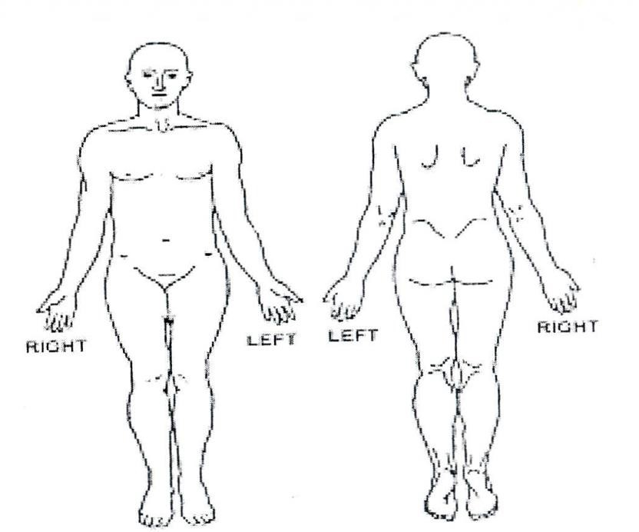

Please mark on the figure(s) below the location of any implant or metal inside of or on your body.

Yes, No Electronic implant or device

Yes, No Magnetically-activated implant or device

Yes, No Neurostimulation system (Deep Brain Stimulator)

Yes, No Spinal cord stimulator

Yes, No Internal electrodes or wires

Yes, No Bone growth/bone fusion stimulator

Yes, No Cochlear, otologic, or other ear implant

Yes, No Insulin or other infusion pump

Yes, No Implanted drug infusion device

Yes, No Any type of prosthesis (eye, penile, etc.)

Yes, No Heart valve prosthesis

Yes, No Eyelid spring or wire

Yes, No Artificial or prosthetic limb

Yes, No Metallic stent, filter, or coil

Yes, No Shunt (spinal or intraventricular)

Yes, No Vascular access port and/or catheter

Yes, No Radiation seeds or implants

Yes, No Swan-Ganz or thermodilution catheter

Yes, No Medication patch (Nicotine, Nitroglycerine)

**IMPORTANT INSTRUCTIONS**

Before entering the MR environment or MR system room, you must remove all metallic objects including hearing aids, dentures, partial plates, keys, beeper, cell phone, eyeglasses, hair pins, barrettes, jewelry, body piercing jewelry, watch, safety pins, paperclips, money clip, credit cards, bank cards, magnetic strip cards, coins, pens, pocket knife, nail clipper, tools, clothing with metal fasteners, & clothing with metallic threads.

Please consult the MRI Technologist or Radiologist if you have any question or concern BEFORE you

Yes, No Any metallic fragment or foreign body

Yes, No Wire mesh implant

Yes, No Tissue expander (e.g., breast)

Yes, No Joint replacement (hip, knee, etc.)

Yes, No Bone/joint pin, screw, nail, wire, plate, etc.

Yes, No IUD, diaphragm, or pessary

Yes, No Dentures or partial plates

Yes, No Tattoo or permanent makeup

Yes, No Body piercing jewelry

Yes, No Hearing aid

(Remove before entering MR system room)

Yes, No Other implant

Yes, No Breathing problem or motion disorder

Yes, No Claustrophobia

Yes, No Color contact lenses

**NOTE: You are required to wear earplugs or other hearing protection during the MRI procedure.**

I attest that the above information is correct to the best of my knowledge. I read and understand the contents of this form and had the opportunity to ask questions regarding the information on this form and regarding the MR procedure that I am about to undergo.

Signature of Person Completing Form: Date: / /

Signature Initials

Screened By: Date: / /

Signature Initials